Longitudinal outcomes from a pilot randomized controlled trial of telehealth acceptance-enhanced behavior therapy for adolescents with trichotillomania
Julie M. Petersen, M.S.¹
Jennifer L. Barney, M.S.¹
Jeremy Fruge, M.S.¹
Eric B. Lee, Ph.D.²
Michael E. Levin, Ph.D.¹
Michael P. Twohig, Ph.D.¹
¹Utah State University
²Southern Illinois University

Correspondence concerning this article should be addressed to Julie Petersen, Department of Psychology, Utah State University, 2810 Old Main Hill, Logan, UT 84322, United States. Phone: (435) 527-5140, Email: Juliana.Petersen@usu.edu

Highlights
- Medium to large decreases were found over time for trichotillomania severity
- Medium to large decreases were found over time for trichotillomania distress
- Improvements over time were also found for general functioning
- Trichotillomania-related psychological inflexibility improved
- No significant effects were found for general or parent psychological inflexibility

Abstract

Trichotillomania is a chronic and impairing disorder typically beginning in youth. There is growing research on the use of acceptance-enhanced behavior therapy (AEBT) for trichotillomania in youth. However, few studies explore long-term outcomes for youth who receive treatment for trichotillomania, particularly AEBT. The current study presents longitudinal data from a pilot randomized controlled trial utilizing AEBT for adolescents with trichotillomania. Twenty-eight adolescents and their caretakers completed measures at pre-treatment, post-treatment, three-, six-, and 12-month follow-up timepoints. Medium to large decreases were found over time for adolescent and parent-reported trichotillomania severity, trichotillomania-related distress, and mental health functioning. Results also indicated small and medium improvements in adolescent-reported trichotillomania-related psychological inflexibility. No significant effects were found for youth-reported general psychological inflexibility or parental psychological inflexibility. These results present preliminary and promising long-term outcomes following AEBT for trichotillomania in adolescents, adding to growing evidence that AEBT may be an appropriate treatment for youth with trichotillomania.
Keywords: trichotillomania, adolescents, acceptance-enhanced behavior therapy, longitudinal
Longitudinal outcomes from a pilot randomized controlled trial of telehealth acceptance-enhanced behavior therapy for adolescents with trichotillomania

Trichotillomania (hair pulling disorder) is a psychiatric condition characterized by repetitive hair pulling that results in noticeable hair loss from the pulling site (American Psychiatric Association [APA], 2013). Individuals may pull out hairs from any site on the body, but the most common areas include the scalp, eyebrows, and eyelashes (Woods & Houghton, 2006). In addition to hair-pulling, diagnostic criteria for trichotillomania includes unsuccessful attempts to control hair pulling and psychological distress and/or functional impairment associated with one’s hair pulling (APA, 2013). Symptoms of trichotillomania often emerge during childhood, with 10-13 years old as the average age of onset and an estimated prevalence of 1–3.5% (Christenson et al., 1991; Franklin et al., 2010). Children and adolescents with trichotillomania often report impaired executive functioning, general functioning, and elevated levels of depression and anxiety symptoms (Flessner et al., 2016; Lewin et al., 2009; Walther et al., 2014). However, research on the treatment of trichotillomania in young people is limited.
Research into effective interventions for trichotillomania in youth has increased over the past three decades, with habit reversal training (HRT) emerging as the gold standard treatment (Farhat et al., 2020). Although HRT has been demonstrated as effective in decreasing hair pulling across multiple clinical trials for youth (e.g., Rahman et al., 2017), many youth still report hair pulling symptoms at post-treatment and relapse is common (Franklin et al., 2011; Franklin et al., 2008). Theories suggest that the limitations of HRT may be due to a lack of targeted intervention strategies to address the internal experiences that often accompany hair pulling (e.g., emotional distress, urges, and cognitions). Thus, recent clinical trials have been exploring the use of adjunctive psychological interventions, such as dialectical behavioral therapy (DBT) or acceptance and commitment therapy (ACT), paired with HRT to address these concerns (Woods & Houghton, 2014).
ACT paired with HRT has been the most widely studied adjunctive treatment approach for trichotillomania, often referred to as acceptance-enhanced behavior therapy (AEBT; Woods & Twohig, 2008). AEBT has been found as effective in reducing hair pulling severity, impairment ratings, and co-occurring psychological symptoms for youth with trichotillomania when delivered through an individual, in-person treatment format (Fine et al., 2012), an in-person group format (Haaland et al., 2017), and through individual telehealth sessions (Lee et al., 2018; Twohig et al., 2021). Additionally, Lee and colleagues (2018) found that many AEBT treatment responders continued to maintain their progress within the three months following treatment. Similarly, Haaland (2017) found that 60% of AEBT treatment responders reported maintaining their progress at one year follow-up.
While research into the efficacy of AEBT for trichotillomania in youth is promising, limitations exist. Despite the growing understanding of trichotillomania as a disorder beginning in childhood and its associations with high rates of morbidity, comorbidity and functional impairment, research into early and effective interventions for pediatric samples is still nascent. A recent systematic review (Adler et al., 2020) and meta-analysis (Farhat et al., 2020) of empirical studies testing the efficacy of behavioral and/or pharmacological treatments for pediatric trichotillomania only identified six and five studies for inclusion, respectively. The findings of these reviews indicated that no psychopharmacological interventions examined to date have demonstrated efficacy in reducing trichotillomania symptoms in youth. Additionally, the results of trials examining behavioral interventions were largely mixed (e.g., 25–76% clinical responder status) and consisted of small sample sizes that limit their generalizability. Knowledge surrounding the maintenance of therapeutic gains following interventions for pediatric trichotillomania is even more limited, with only one randomized controlled trial looking at eight-week follow-up analyses (Franklin et al., 2011) and one open trial including six-month follow-ups (Tolin et al., 2007).
The current study therefore seeks to contribute to the existent literature by presenting longitudinal follow-up data from a recent pilot randomized controlled trial (Twohig et al., 2021) on telehealth AEBT for adolescents with trichotillomania. The overarching purpose of this study is to provide more information regarding the maintenance of therapy gains in young people following AEBT for trichotillomania. We predicted that adolescents and their caregivers would report maintained and reduced trichotillomania symptoms, distress, and psychological inflexibility over time.
Methods
Participants
Participants included 28 adolescents and at least one caregiver per participant. All participants were residents of [removed for masked review] and were located across the state. The majority of participants were female (68%), within an age range of 12 to 16 years old (M = 13.9; SD = 1.3). Sixteen participants (57.1%) met diagnostic criteria for at least one comorbid diagnosis, most commonly depressive (42.8%) and anxiety disorders (ranging from 7–10%). Approximately 40 percent of the participants were currently taking a selective serotonin reuptake inhibitor (SSRI) and 26% were taking a stimulant medication for attention deficit hyperactivity disorder (ADHD). Twenty-eight participants engaged in the study and variable numbers of participants completed data at the post-treatment and follow-up time points. Refer to Figure 1 for participant retention numbers at post-treatment, three-, six-, and 12-month follow-up timepoints. All participants lost to follow-up (ranging from 16-43%) were because participants were not responsive to contact via email or text. There did not appear to be differences between participants who did or did not complete follow-ups based on a non-statistical review of the data.
Participants were recruited from online postings, advertisements in newspapers, and referrals from other healthcare professionals. Participants were eligible for the study if they: (a) met the Diagnostic and Statistical Manual of Mental Disorders, fifth edition, (DSM-5) diagnostic criteria for trichotillomania (APA, 2013), (b) were currently seeking treatment primarily for trichotillomania or problematic hair-pulling; (c) were between the ages of 12 to 17; (d) were fluent in English; (e) were not currently receiving psychotherapy or starting/changing any psychotropic medication in the past 30 days; (f) were residing in the state where the clinical supervisor was licensed.
General overview of study procedures
In brief, the study was a pilot randomized controlled trial comparing 10 sessions of online AEBT for trichotillomania to a waitlist control. Sessions were primarily spent with the adolescent, but the remaining 10 minutes were allotted for review of treatment skills and concepts with the parent, as appropriate. Those randomized to the waitlist received treatment following 12 weeks. For information on the randomization procedures, treatment materials, session outline, and therapists, refer to the original pilot trial (Twohig et al., 2021).
Measures
Measures were given to adolescents and caregivers at pre-treatment, post-treatment, three-month, six-month, and twelve-month follow-up timepoints. All measures were given using an online survey platform. Participants were sent two links at each data collection time point, one survey battery for parents and one for the adolescents.
Trichotillomania Scale for Children – Youth and Parent Versions (TSC-Y & TSC-P; Tolin et al., 2008). The TSC-Y and TSC-P are self-report measures for youth and parent-rated trichotillomania symptoms with subscales for severity and distress/impairment. For each of the 12 items, the youth or parent chose the best fitting response from a range of multiple options. Example items include “During the last week, how guilty do you feel about hair pulling?” and “During the last week, how upset at him/herself did your child get because of hair pulling or bald patches?” The responses are rated from 0 to 2, summed into two subscales, and divided by five or seven for the severity or distress/impairment subscales respectively. Higher scores indicate greater trichotillomania symptoms. The TSC-Y and TSC-P have demonstrated good internal consistency in the current sample (αs = .89 for each) and acceptable validity, internal consistency, and reliability in previous research (Tolin et al. 2008). Additionally, a recent meta-analysis found that the TSC-Y and TSC-P were both sensitive to change (Farhat et al., 2020). Both the caregiver and adolescent completed the TSC-P AND TSC-Y, respectively, at all timepoints.
Youth Outcome Questionnaire 30.2 Self-Report and Parent-Report Versions (YOQ-C & YOQ-P; Burlingame et al., 1998). The YOQ-C and YOQ-P are each 30-item measures of self- and parent-rated youth distress and well-being. Example items include “I am sad or unhappy” and “My child’s emotions are strong and change quickly.” Items are rated on a five-point, Likert-type scale (0 = never or almost never to 4 = always or almost always) and these responses are summed into a total score (range = 0 to 120). Scores for the YOQ-C of 30 or higher and scores on the YOQ-P of 29 or higher are considered clinically significant. The YOQ-C and YOQ-P both demonstrated excellent internal consistency in the current sample (α = .95 for each) and have good internal consistency, test-retest reliability, and concurrent validity in past research (Ridge et al., 2009). Previous outcome research has also demonstrated that the YOQ is sensitive to change over time (e.g., Ricard et al., 2013; Russell et al., 2018). Both the caregiver and adolescent completed the YOQ-P and YOQ-C, respectively, at all timepoints.
Acceptance and Action Questionnaire for Trichotillomania (AAQ-TTM; Houghton et al., 2014). The AAQ-TTM is a measure of psychological flexibility specifically designed for trichotillomania-related internal experiences. Examples of questions from the AAQ-TTM include, “Urges to pull are bad,” and “When I feel the urge to pull, I am unable to take care of my responsibilities.” The nine items in the AAQ-TTM are rated on a seven-point Likert-type scale (1 = never true to 7 = always true) and are summed into a total score (range = 7 to 63), with higher scores indicating higher levels of psychological flexibility (i.e., lower levels of psychological inflexibility). The AAQ-TTM demonstrated excellent internal consistency in the current study (α = .91); previous samples indicate adequate reliability and validity (Houghton et al., 2014), along with sensitivity to change (e.g., Lee et al., 2018). Only the adolescent completed the AAQ-TTM at all timepoints.
Avoidance and Fusion Questionnaire for Youth – short form (AFQ-Y8; Greco et al., 2008). The AFQ-Y8 is an eight-item self-report measure of youth psychological inflexibility, specifically assessing avoidance and fusion. Example items assessing avoidance and fusion from the AFQ-Y8 are “I am afraid of my feelings,” and “The bad things I think about myself must be true.” Each item is rated on a five-point, Likert-type scale (0 = not at all true to 4 = very true). All items are summed for a total score ranging from 0 to 32, with higher scores indicating higher levels of psychological inflexibility. The AFQ-Y demonstrated good internal consistency in the current sample (α = .87) and acceptable reliability and validity in past samples (Greco et al., 2008). Previous trials have demonstrated the AFQ-Y8 is sensitive to change (e.g., Hancock et al., 2018). Only the adolescent completed the AFQ-Y at all timepoints.
Parental Acceptance Questionnaire (6-PAQ; Greene et al., 2015). The 6-PAQ is an 18-item self-report measure that was designed to assess six processes that are believed to contribute psychological flexibility among parents. Examples of items from the 6-PAQ include, “When interacting with my child, I focus on our time together” and “If someone criticizes my parenting, I must be a bad parent.” The six subscales are acceptance, defusion, being present, self as context, values, and committed action in relation to parenting practices. Each item is rated on a four-point, Likert-type scale (1 = strongly disagree/never to 4 = strongly agree/almost always). Items 1, 2, 5, 7, 10, 15, and 18 are reverse scored and then all items are summed for a total score. Lower scores indicate higher levels of parental psychological flexibility (i.e., low psychological inflexibility). The 6-PAQ demonstrated unacceptable internal consistency in the current sample (α = .57). However, past research has found reliability and validity of the 6-PAQ to be ranging from acceptable to good (Greene et al., 2015). Previous research on parenting interventions indicated good sensitivity to change (e.g., Flujas-Contreras et al., 2021). Only the caregiver completed the 6-PAQ at all timepoints.
Statistical analyses
All analyses were conducted using R in RStudio, version 4.1.1 (R Core Team, 2021). The following packages were used in analyses: tidyverse (Wickham et al., 2019), furniture (Barrett & Brignone, 2017), dplyr (Mailund, 2019), ggplot2 (Wickham, 2011), cowplot (Wilke et al., 2019), magrittr (Bache et al., 2020), stringr (Wickham & Wickham, 2019), effectsize (Ben-Shachar et al., 2020), texreg (Leifeld, 2013), and lmerTest (Kuznetsova et al., 2017). Because this paper is reporting results from a previously published pilot randomized controlled trial (Twohig et al., 2021), the waitlist and treatment groups were combined to evaluate effects of treatment over time. For the present study, the waitlist group’s pre-treatment point used the “post-waitlist” measures, as this timepoint was right before beginning treatment and presented the most conservative method (as opposed to using the pre-waitlist timepoint).
Multilevel models (MLM) were used to evaluate change over time in an intention-to-treat sample for the main outcomes of parent and youth-rated trichotillomania severity, trichotillomania-related distress, and mental health functioning. MLMs were also used to evaluate process outcomes of youth psychological inflexibility, trichotillomania-specific psychological inflexibility, and parental psychological inflexibility. Parent and youth outcomes were all tested in separate models. Each model contained a fixed effect of time (i.e., weeks) and a random intercept for each participant. Final models used maximum likelihood criteria and p values are based Satterthwaite’s method. Effect sizes using Hedges’ g were also calculated for within-group changes across timepoints (pre-treatment to posttreatment, pre-treatment to three-month follow-up, etc.). For effect sizes, .2 is considered a small effect, .5 a medium effect, and .8 a large effect.
Results
Means and standard deviations for all outcomes and timepoints for youth and parent measures can be found in Table 1. Estimated marginal means and 95% confidence intervals for youth models can be found in Table 2 and in Table 3 for parent models. Effect sizes for youth and parent outcomes can be found in Table 4. Figure 1 illustrates participant retention across follow-up timepoints.
Trichotillomania severity and distress
Models for both parent- and youth-reported trichotillomania severity had a significant effect of time. There was a significant decrease in both parent- and youth-reported trichotillomania severity over time (See Figure 2). For the youth report, there were large effects from pre-treatment to posttreatment (Hedges’ g = 1.27), three-month follow-up (1.04), six-month follow-up (1.34), and 12-month follow-up (1.09). For the parent report, there were medium to large effects from pre-treatment to posttreatment (Hedges’ g = 1.08), three-month follow-up (.71), six-month follow-up (.99), and 12-month follow-up (1.01).
Models for both parent- and youth-reported trichotillomania-related distress had a significant effect of time. There was a significant decrease in both parent- and youth-reported trichotillomania severity over time (See Figure 2). For the youth report, there were medium effects for pre-treatment to posttreatment (Hedges’ g = .67), three-month follow-up (.62), six-month follow-up (.75), and 12-month follow-up (.55). For the parent report, there were medium to large effects for pre-treatment to posttreatment (1.04), three-month follow-up (.62), six-month follow-up (1.02), and 12-month follow-up (.82).
Clinical responder status. Both TSC-Y and TSC-P total scores were examined for responder status from pre-treatment to each follow-up point. Based on previous research, a participant was considered a responder if they reported a 25% reduction in TSC-Y scores and/or a 45–50% reduction in TSC-P scores (Farhat et al., 2020). Thus, percent reductions in total TSC scores were calculated for both parent and youth total ratings (see Table 5). Across timepoints, 52–63% of adolescents reported reductions within the clinical responder range. For parents, 16–44% reported reductions within the clinical responder range across timepoints.
Mental health functioning
The model for parent- reported mental health functioning (YOQ-P) had a significant effect of time, with significant decreases from pre-treatment to 12-month follow-up (see Figure 3). For the parent report, there were medium to large effects from pre-treatment to posttreatment (Hedges’ g = .58), three-month (Hedges’ g = .76), six-month (.66), and 12-month follow-up (.86).
The model for youth-reported mental health functioning (YOQ-C) did not have a significant effect of time (see Figure 3). The effect sizes from pre-treatment to three-month follow-up (.39) and six-month follow-up (.25) were small. Pre-treatment to posttreatment and to 12-month follow-up effect sizes were negligible.
Psychological inflexibility
The model for AAQ-TTM, trichotillomania-specific psychological inflexibility, had a significant effect for time, indicating decreases in youth trichotillomania-specific psychological inflexibility from pre-treatment to 12-month follow-up. There were small to medium effects from pre-treatment to posttreatment (Hedges’ g = .41), to three-month (.43), to six-month (.53), and to 12-month follow-up (.47).
The model for AFQ-Y8, general youth psychological inflexibility, did not have a significant effect for time. The effect sizes from pre-treatment to all follow-up timepoints were negligible. The model for parental psychological inflexibility (6-PAQ) did not have a significant effect of time. All effect sizes were negligible except for pre-treatment to 12-month follow-up, which was small (g = .31).
Discussion
The results of this follow-up study provide evidence that treatment gains from online-delivered acceptance-enhanced behavior therapy (AEBT) for adolescents with trichotillomania may have been maintained up to one year later. The study results suggest improvement in outcome and process variables from pre-treatment to three-, six-, and 12-months as reported by the adolescent participants and their parent. Moreover, it appears that treatment gains were generally maintained over the 12-month follow-up period with only slight worsening in some scores over time. Treatment studies of youth trichotillomania are very limited with only four trials currently published, one of which includes a mixed adult and adolescent sample (Franklin et al., 2011; Lee et al., 2018; Tolin et al., 2007; Twohig et al., 2021). Of those, only two incorporated follow-up assessments at eight weeks and six months. Thus, this study presents important findings, particularly because follow-up data is especially scarce in this population and has not been examined past a six-month period.
With regard to trichotillomania symptoms, both parents and adolescents on average reported large effects of treatment at all points of follow-up. They likewise reported medium to large effects of treatment with regard to trichotillomania-related distress. However, parent and adolescent ratings of trichotillomania recovery (i.e., responder status) often differed, with varying percentages of parents and adolescents reporting recovery (e.g., adolescent and parent responder status at 58% to 30%, respectively, at six-month follow-up). Similarly, parents reported medium to large improvements in mental health functioning over the 12-months of follow-up, while adolescents reported small to negligible improvements. Reductions in symptom severity coincided with increased mental health functioning; however, on average, parent and adolescent reports also disagreed on the amount of change.
The variations in parent-adolescent agreement could be attributed to contextual experiences of trichotillomania symptoms and/or mental health functioning. For example, an adolescent may be less aware of their pulling at home when they are with the parent, thus contributing to higher severity ratings from the parent who may not witness the adolescent resisting at school or other places. Alternatively, variables such as parental psychopathology, mood, gender, income, and more have been associated with parent-youth disagreement across a variety of domains (e.g., Abate et al., 2017; Poulain et al., 2020). Additionally, some researchers have explored measurement invariance as a possible explanation for differences between parent and youth reports; one study found differences in item function as a possible influence on dyadic agreement on anxiety symptoms (Olino et al., 2018). While this study does not account for such variables, future research should consider both demographic and psychometric factors in parent-youth disagreement.
Lastly, adolescent-rated and trichotillomania-specific psychological inflexibility demonstrated small to medium decreases throughout the follow-up period. However, the general measure of youth psychological inflexibility (AFQ-Y8) and parental psychological inflexibility (6-PAQ) demonstrated no meaningful changes. The lack of change in general youth psychological inflexibility and parental psychological inflexibility was not completely unexpected, as previous research has demonstrated the value of condition-specific psychological inflexibility measures in similar studies (e.g., Ong et al., 2019). Furthermore, the 6-PAQ did not support adequate reliability in the present sample, suggesting possible limitations in measure functioning and interpretation.
On average, the participants in the current study saw significant treatment gains. However, there are individuals who did not experience these gains and those who may have only seen a portion of the progress they were looking for. Further examination of individual-level processes of change could help to better tailor the treatment to the individual and their parent and home. This is especially relevant for the adolescent participants who reported smaller mental health functioning gains than their parents. Perhaps there are person-level concerns that are not being addressed as well as they could be via a structured treatment package, even a flexible one such as AEBT. Individualized care could also impact maintenance, as reasons for symptom relapse are surely varied and personal. Ongoing aftercare that includes periodic personalized check-ins and/or self-training resources could potentially help better maintain treatment gains and even foster further recovery and increase quality of life.
The limitations of the original treatment study remain, including lack of objective measurement, different developmental stages of participants, and a need for a more diverse sample (removed for masked review). However, with regard to collecting and reporting the follow-up data, only a few additional study limitations were introduced. First, we did not collect information on therapy or medication changes during the follow-up period. We also did not collect information on previous treatment using ACT and HRT prior to study participation. This important information would have allowed for better discernment of treatment effects over time; without this information, our findings are significantly limited. Additionally, we lost some participants over the course of the yearlong follow-up. We were pleased that our efforts to retain participants were largely successful, with average retention rates of 80% (parents) and 68% (adolescents) across the three follow-up points. However, the loss of participants over time reduces the sample size and thus the power of the study and findings. Lastly, the follow-up period was uncontrolled, thus bringing into question how much the improvement is related to time as opposed to treatment maintenance. Ultimately, it would be important for future research to focus on increased sample sizes with clinician-rated follow-up measures in order to better inform treatment outcomes and understand long-term maintenance of gains.
The current findings are generally promising, with parents and adolescents reporting significant, meaningful treatment gains from pretreatment to 12-months posttreatment. While this study demonstrates the utility of AEBT for adolescents with trichotillomania, it is only one of very few studies on the topic. There remains a dearth of data regarding trichotillomania treatment, especially for youth. There is much room for the continued study of youth trichotillomania and how we can best improve and tailor treatments to provide lasting change.

References

Abate, C., Lippé, S., Bertout, L., Drouin, S., Krajinovic, M., Rondeau, É., Sinnett,D., Laverdiére, C., & Sultan, S. (2018). Could we use parent report as a valid proxy of child report on anxiety, depression, and distress? A systematic investigation of father–mother–child triads in children successfully treated for leukemia. Pediatric Blood & Cancer, 65(2), e26840.
American Psychiatric Association, Diagnostic and statistical manual of mental disorders (DSM- 5®). 2013, Arlington, VA: Author.
Bache, S. M., Wickham, H., & Bache, M. S. M. (2020). Package ‘magrittr’.
Barrett, T. S., & Brignone, E. (2017). Furniture for Quantitative Scientists. R J., 9(2), 142.
Bate, K. S., Malouff, J. M., Thorsteinsson, E. T., & Bhullar, N. (2011). The efficacy of habit reversal therapy for tics, habit disorders, and stuttering: A meta-analytic review. Clinical Psychology Review, 31(5), 865-871.
Ben-Shachar, M. S., Lüdecke, D., & Makowski, D. (2020). effectsize: Estimation of effect size indices and standardized parameters. Journal of Open Source Software, 5(56), 2815.
Christenson, G. A., Pyle, R. L., & Mitchell, J. E. (1991). Estimated lifetime prevalence of trichotillomania in college students. The Journal of Clinical Psychiatry, 52(10), 415–417.
Farhat, L. C., Olfson, E., Levine, J. L., Li, F., Franklin, M. E., Lee, H. J., ... & Bloch, M. H. (2020). Measuring treatment response in pediatric trichotillomania: A meta-analysis of clinical trials. Journal of Child and Adolescent Psychopharmacology, 30(5), 306-315.
Fine, K. M., Walther, M. R., Joseph, J. M., Robinson, J., Ricketts, E. J., Bowe, W. E., & Woods, D. W. (2012). Acceptance-enhanced behavior therapy for trichotillomania in adolescents. Cognitive and Behavioral Practice, 19(3), 463-471.
Flessner, C. A., Busch, A. M., Heideman, P. W., & Woods, D. W. (2008). Acceptance-enhanced behavior therapy (AEBT) for trichotillomania and chronic skin picking: Exploring the effects of component sequencing. Behavior Modification, 32(5), 579-594.
Flessner, C. A., Brennan, E., Murphy, Y. E., & Francazio, S. (2016). Impaired executive functioning in pediatric trichotillomania (Hair Pulling Disorder). Depression and Anxiety, 33(3), 219-228.
Flujas-Contreras, J. M., García-Palacios, A., & Gómez, I. (2021). Effectiveness of a web-based intervention on parental psychological flexibility and emotion regulation: A pilot open trial. International Journal of Environmental Research and Public Health, 18(6), 2958.
Franklin, M. E., Flessner, C. A., Woods, D. W., Keuthen, N. J., Piacentini, J. C., Moore, P., ... & Board, T. L. C. S. A. (2008). The child and adolescent trichotillomania impact project: Descriptive psychopathology, comorbidity, functional impairment, and treatment utilization. Journal of Developmental & Behavioral Pediatrics, 29(6), 493-500.
Franklin, M. E., Edson, A. L., & Freeman, J. B. (2010). Behavior therapy for pediatric trichotillomania: exploring the effects of age on treatment outcome. Child and Adolescent Psychiatry and Mental Health, 4(1), 1-6.
Franklin, M. E., Zagrabbe, K., & Benavides, K. L. (2011). Trichotillomania and its treatment: A review and recommendations. Expert Review of Neurotherapeutics, 11(8), 1165-1174.
Grant, J. E., Redden, S. A., Medeiros, G. C., Odlaug, B. L., Curley, E. E., Tavares, H., & Keuthen, N. J. (2017). Trichotillomania and its clinical relationship to depression and anxiety. International Journal of Psychiatry in Clinical Practice, 21(4), 302-306.
Haaland, Å. T., Eskeland, S. O., Moen, E. M., Vogel, P. A., Haseth, S., Mellingen, K., ... & Hummelen, B. (2017). ACT-enhanced behavior therapy in group format for Trichotillomania: An effectiveness study. Journal of Obsessive-Compulsive and Related Disorders, 12, 109-116.
Hancock, K. M., Swain, J., Hainsworth, C. J., Dixon, A. L., Koo, S., & Munro, K. (2018). Acceptance and commitment therapy versus cognitive behavior therapy for children with anxiety: Outcomes of a randomized controlled trial. Journal of Clinical Child & Adolescent Psychology, 47(2), 296-311.
Kuznetsova, A., Brockhoff, P. B., & Christensen, R. H. (2017). lmerTest package: Tests in linear mixed effects models. Journal of Statistical Software, 82(1), 1-26.
Lee, E. B., Haeger, J. A., Levin, M. E., Ong, C. W., & Twohig, M. P. (2018). Telepsychotherapy for trichotillomania: A randomized controlled trial of ACT enhanced behavior therapy. Journal of Obsessive-Compulsive and Related Disorders, 18, 106-115.
Lee, E. B., Homan, K. J., Morrison, K. L., Ong, C. W., Levin, M. E., & Twohig, M. P. (2020). Acceptance and commitment therapy for trichotillomania: A randomized controlled trial of adults and adolescents. Behavior modification, 44(1), 70-91.
Leifeld, P. (2013). texreg: Conversion of statistical model output in R to LATEX and HTML tables. Journal of Statistical Software, 55(8), 1-24.
Lewin, A. B., Piacentini, J., Flessner, C. A., Woods, D. W., Franklin, M. E., Keuthen, N. J., ... & Stein, D. J. (2009). Depression, anxiety, and functional impairment in children with trichotillomania. Depression and Anxiety, 26(6), 521-527.
Mailund, T. (2019). Manipulating data frames: dplyr. In R Data Science Quick Reference (pp. 109-160). Apress, Berkeley, CA.
Olino, T. M., Finsaas, M., Dougherty, L. R., & Klein, D. N. (2018). Is parent–child disagreement on child anxiety explained by differences in measurement properties? An examination of measurement invariance across informants and time. Frontiers in Psychology, 9, 1295.

Ong, C. W., Lee, E. B., Levin, M. E., & Twohig, M. P. (2019). A review of AAQ variants and other context-specific measures of psychological flexibility. Journal of Contextual Behavioral Science, 12, 329-346.
Rahman, O., McGuire, J., Storch, E. A., & Lewin, A. B. (2017). Preliminary randomized controlled trial of habit reversal training for treatment of hair pulling in youth. Journal of Child and Adolescent Psychopharmacology, 27(2), 132-139.
Ricard, R. J., Lerma, E., & Heard, C. C. (2013). Piloting a dialectical behavioral therapy (DBT) infused skills group in a disciplinary alternative education program (DAEP). The Journal for Specialists in Group Work, 38(4), 285-306.
Ridge, N. W., Warren, J. S., Burlingame, G. M., Wells, M. G., & Tumblin, K. M. (2009). Reliability and validity of the youth outcome questionnaire self‐report. Journal of Clinical Psychology, 65(10), 1115-1126.
Russell, K. C., & Gillis, H. L. L. (2018). An evaluation of Alaska Crossings: Comparison of the client status review and the youth outcome questionnaire. Journal of Therapeutic Schools and Programs, 127.
Tolin, D. F., Diefenbach, G. J., Flessner, C. A., Franklin, M. E., Keuthen, N. J., Moore, P., Piacentini, J., Stein, D.J., & Woods, D. W. (2008). The trichotillomania scale for children: Development and validation. Child Psychiatry and Human Development, 39(3), 331-349.
Tolin, D. F., Franklin, M. E., Diefenbach, G. J., Anderson, E., & Meunier, S. A. (2007). Pediatric trichotillomania: Descriptive psychopathology and an open trial of cognitive behavioral therapy. Cognitive Behaviour Therapy, 36(3), 129-144.
Twohig, M. P., & Woods, D. W. (2004). A preliminary investigation of acceptance and commitment therapy and habit reversal as a treatment for trichotillomania. Behavior Therapy, 35(4), 803-820.
Walther, M. R., Snorrason, I., Flessner, C. A., Franklin, M. E., Burkel, R., & Woods, D. W. (2014). The trichotillomania impact project in young children (TIP-YC): Clinical characteristics, comorbidity, functional impairment and treatment utilization. Child Psychiatry & Human Development, 45(1), 24-31.
Wickham, H. (2011). ggplot2. Wiley Interdisciplinary Reviews: Computational Statistics, 3(2), 180-185.
Wickham, H., Averick, M., Bryan, J., Chang, W., McGowan, L. D. A., François, R., ... & Yutani, H. (2019). Welcome to the Tidyverse. Journal of Open Source Software, 4(43), 1686.
Wickham, H., & Wickham, M. H. (2019). Package ‘stringr’.
Wilke, C. O., Wickham, H., & Wilke, M. C. O. (2019). Package ‘cowplot’. Streamlined Plot Theme and Plot Annotations for ‘ggplot2.
Woods, D. W., Flessner, C. A., Franklin, M. E., Keuthen, N. J., Goodwin, R. D., Stein, D. J., & Walther, M. R. (2006). The Trichotillomania Impact Project (TIP): exploring phenomenology, functional impairment, and treatment utilization. Journal of Clinical Psychiatry, 67(12), 1877.
Woods, D. W., Wetterneck, C. T., & Flessner, C. A. (2006). A controlled evaluation of acceptance and commitment therapy plus habit reversal for trichotillomania. Behaviour Research and Therapy, 44(5), 639-656.
Woods, D. W., & Houghton, D. C. (2014). Diagnosis, evaluation, and management of trichotillomania. Psychiatric Clinics, 37(3), 301-317.

Acknowledgments

This study was supported by funding from the Huntsman Foundation.

Given their role as an Editorial Board Member, Michael Twohig had no involvement in the peer-review of this article and had no access to information regarding its peer-review. The authors declare no conflict of interest.

Table 1
Means and standard deviation for youth and parent-rated outcomes
 | Pretreatment | Posttreatment | Three-month follow-up | Six-month follow-up | 12-month follow-up
TSC-Y Severity | 1.3 (0.4) | 0.6 (0.6) | 0.8 (0.5) | 0.7 (0.5) | 0.7 (0.6)
TSC-Y Distress | 0.8 (0.5) | 0.5 (0.5) | 0.5 (0.6) | 0.4 (0.5) | 0.5 (0.6)
AFQ-Y8 | 6.1 (6.0) | 5.8 (4.7) | 5.4 (5.6) | 7.2 (8.0) | 7.2 (7.0)
AAQ-TTM¹ | 42.0 (12.7) | 47.5 (13.5) | 47.8 (13.0) | 49.1 (13.7) | 48.3 (13.6)
YOQ-C | 25.0 (21.5) | 22.1 (14.9) | 17.4 (13.7) | 19.8 (19.0) | 22.1 (18.7)
TSC-P Severity | 1.3 (0.4) | 0.9 (0.5) | 1.0 (0.5) | 0.9 (0.5) | 0.8 (0.7)
TSC-P Distress | 0.9 (0.4) | 0.5 (0.4) | 0.6 (0.6) | 0.4 (0.5) | 0.5 (0.6)
6-PAQ | 31.6 (4.9) | 31.2 (5.5) | 31.4 (6.4) | 32.5 (6.2) | 29.9 (6.1)
YOQ-P | 30.6 (18.1) | 20.7 (15.3) | 18.3 (11.4) | 19.2 (15.3) | 16.6 (13.2)
Note. TSC-Y = Trichotillomania Scale for Children (Youth-Report); AFQ-Y8 = Avoidance and Fusion Questionnaire for Youth; AAQ-TTM = Acceptance and Action Questionnaire for Trichotillomania; YOQ-C = Youth Outcomes Questionnaire (Youth-Report); TSC-P = Trichotillomania Scale for Children (Parent-Report); YOQ-P = Youth Outcomes Questionnaire (Parent-Report); 6-PAQ = Parental Acceptance Questionnaire
¹Higher scores indicate greater improvement.
Table 2
Regression coefficients and 95% confidence intervals from multilevel models for youth-rated outcomes
 | TSC-Y Severity | TSC-Y Distress | YOQ-Y | AAQ-TTM | AFQ-Y8
(Intercept) | 1.03 [ 0.85; 1.21]* | 0.69 [ 0.49; 0.88]* | 23.51 [17.38; 29.64]* | 43.98 [39.34; 48.62]* | 6.04 [ 3.92; 8.16]*
Weeks | -0.01 [-0.01; -0.00]* | -0.00 [-0.01; -0.00]* | -0.03 [-0.11; 0.05] | 0.06 [ 0.01; 0.11]* | 0.02 [-0.01; 0.04]
AIC | 190.01 | 126.27 | 855.39 | 773.91 | 640.41
BIC | 200.67 | 136.93 | 866.00 | 784.53 | 651.06
Number of observations | 106 | 106 | 105 | 105 | 106
Number of participants | 28 | 28 | 28 | 28 | 28
* 0 outside of confidence interval
Note. TSC-Y = Trichotillomania Scale for Children (Youth-Report); YOQ-C = Youth Outcomes Questionnaire (Youth-Report); AAQ-TTM = Acceptance and Action Questionnaire for Trichotillomania; AFQY = Avoidance and Fusion Questionnaire for Youth; AIC = Akaike Information Criterion; BIC = Bayesian Information Criterion.

Table 3
Regression coefficients and 95% confidence intervals from multilevel models for parent-rated outcomes
 | TSC-P Severity | TSC-P Distress | YOQ-P | PAQ
(Intercept) | 0.71 [ 0.55; 0.88]* | 1.15 [ 0.98; 1.31]* | 26.33 [21.26; 31.40]* | 31.85 [29.91; 33.78]*
Weeks | -0.00 [-0.01; -0.00]* | -0.01 [-0.01; -0.00]* | -0.13 [-0.21; -0.05]* | -0.01 [-0.04; 0.01]
AIC | 153.35 | 178.61 | 884.45 | 650.85
BIC | 164.12 | 189.41 | 895.25 | 661.65
Number of observations | 109 | 110 | 110 | 110
Number of participants | 28 | 28 | 28 | 28
* 0 outside of confidence interval
Note. TSC-P = Trichotillomania Scale for Children (Parent-Report); YOQ-P = Youth Outcomes Questionnaire (Parent-Report); PAQ = Parental Acceptance Questionnaire; AIC = Akaike Information Criterion; BIC = Bayesian Information Criterion.

Table 4
Hedges’ g effect sizes from pre-treatment within the sample for youth and parent measures across timepoints
 | Post-treatment | Three-month | Six-month | 12-month
TSC-Y Severity | 1.27 | 1.04 | 1.34 | 1.09
TSC-Y Distress | .67 | .62 | .75 | .55
YOQ-Y | .15 | .39 | .25 | .14
AAQ-TTM | -.41 | -.43 | -.53 | -.47
AFQ-Y8 | .05 | .12 | -.15 | -.16
TSC-P Severity | 1.08 | .71 | .99 | 1.01
TSC-P Distress | 1.04 | .62 | 1.02 | .82
YOQ-P | .58 | .76 | .66 | .86
6-PAQ | .08 | .04 | -.15 | .31
Note. TSC-Y = Trichotillomania Scale for Children (Youth-Report); YOQ-C = Youth Outcomes Questionnaire (Youth-Report); AAQ-TTM = Acceptance and Action Questionnaire for Trichotillomania; AFQ-Y8 = Avoidance and Fusion Questionnaire for Youth; TSC-P = Trichotillomania Scale for Children (Parent-Report); YOQ-P = Youth Outcomes Questionnaire (Parent-Report); 6-PAQ = Parental Acceptance Questionnaire.

 | Pre-treatment to post-treatment |  | Pre-treatment to three-month follow-up |  | Pre-treatment to six-month follow-up |  | Pre-treatment to 12-month follow-up
 | Youth  (n = 27) | Parent  (n = 25) | Youth  (n = 17) | Parent  (n = 18) | Youth  (n = 17) | Parent  (n = 20) | Youth  (n = 21) | Parent  (n = 21)
TSC Severity (%) | 19  (70.4) | 8  (32.0) | 9  (52.9) | 2  (11.1) | 11  (64.7) | 4  (20.0) | 14  (66.7) | 9  (42.8)
TSC Distress (%) | 13  (48.1) | 13 (52.0) | 7  (41.2) | 9  (50.0) | 9  (52.9) | 9  (45.0) | 10  (47.6) | 12  (57.1)
TSC Total (%) | 17  (62.9) | 11 (44.0) | 9  (52.9) | 3  (16.7) | 10  (58.8) | 6  (30.0) | 11  (52.4) | 9  (42.8)
Table 5
Parent and child clinical responder classifications for trichotillomania severity and distress

Note. TSC = Trichotillomania Scale for Children.
Figure 1. Diagram of participant retention over follow-up timepoints. Starting N = 28; participants lost at each follow-up point were unresponsive to experimenter prompts.
12-month follow-up
Parent (22)
Adolescent (21)
Six-month follow-up
Parent (20)
Adolescent (17)
Three-month follow-up
Parent (18)
Adolescent (17)
Posttreatment
Parent (25)
Adolescent (27)

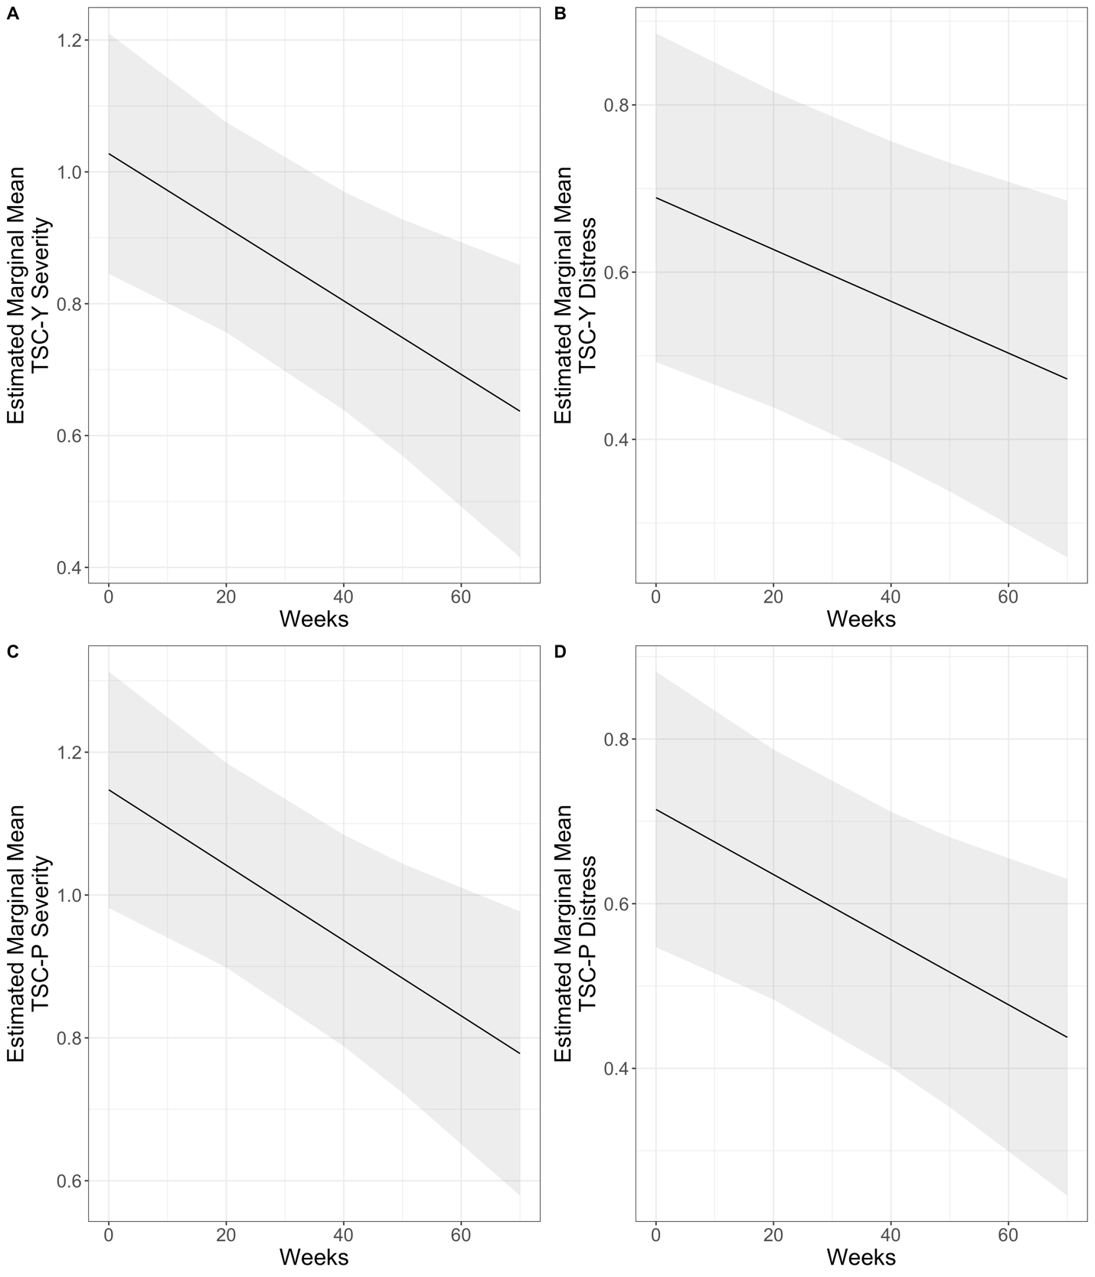
Figure 2. Estimated marginal means and error ribbons from the models for A) TSC-Y severity, B) TSC-Y distress, C) TSC-P severity, and D) TSC-P distress. TSC-Y = Trichotillomania Scale for Children (Youth-Report) and TSC-P = Trichotillomania Scale for Children (Parent-Report).

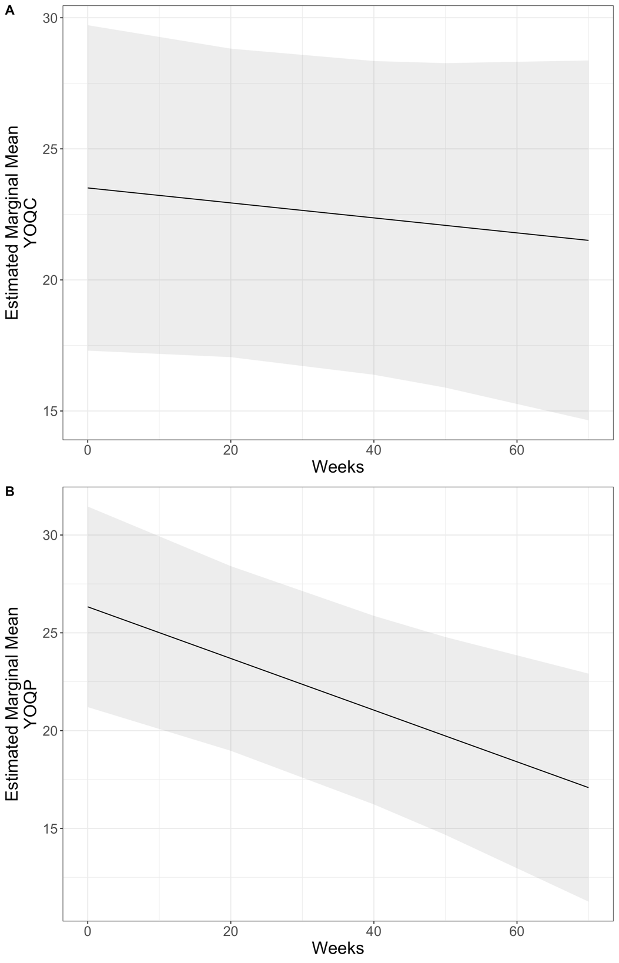
Figure 3. Estimated marginal means and error ribbons from the models for A) YOQ-C (Youth Outcomes Questionnaire Youth-Report) and B) YOQ-P (Youth Outcomes Questionnaire Parent-Report).

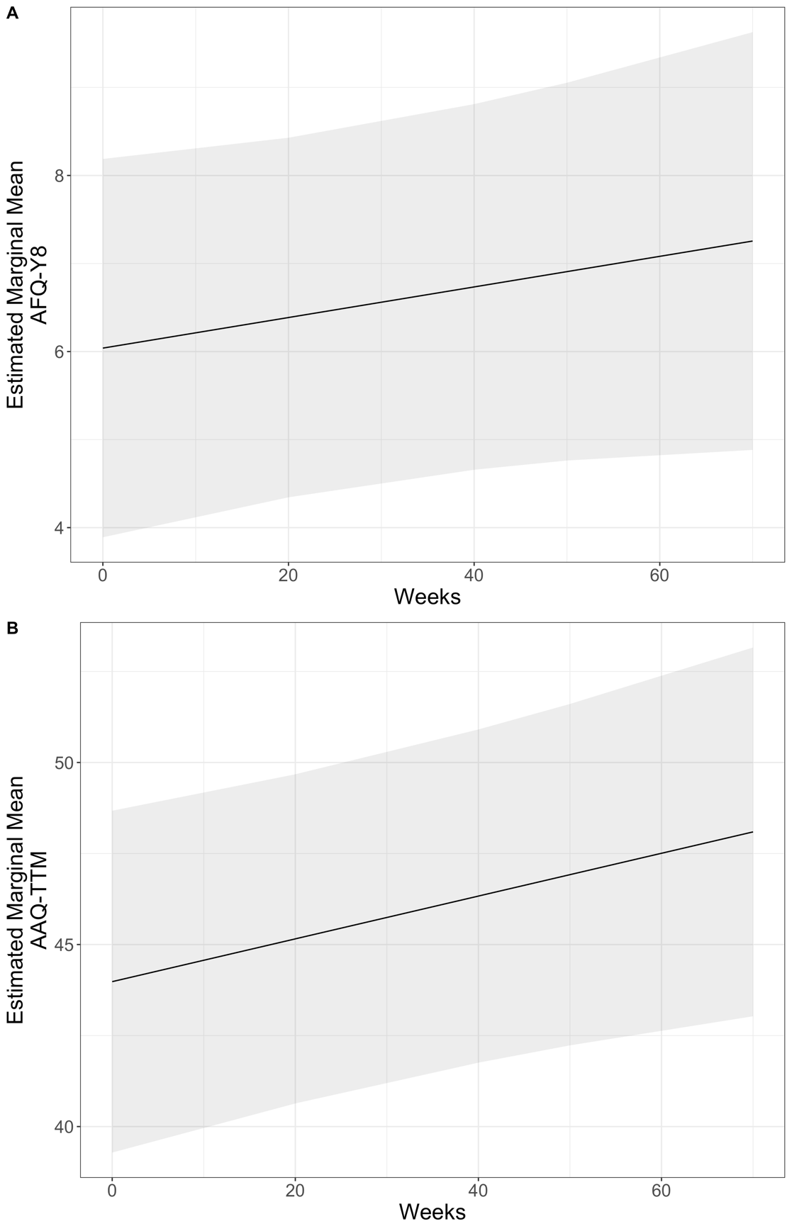
Figure 4. Estimated marginal means and error ribbons from the models for A) AFQ-Y8 and B) AAQ-TTM. AFQ-Y8 = Avoidance and Fusion Questionnaire for Youth and AAQ-TTM = Acceptance and Action Questionnaire for Trichotillomania. Higher scores indicate greater psychological flexibility (i.e., improvement) for the AAQ-TTM and psychological inflexibility for the AFQ-Y8.
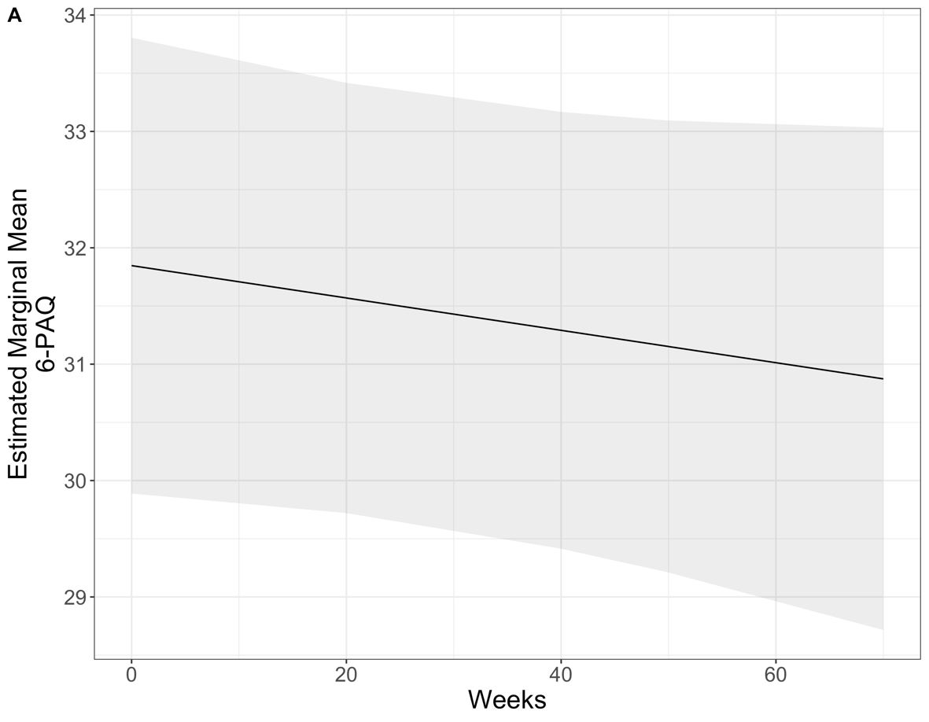
Figure 5. Estimated marginal means and error ribbons from the model for the 6-PAQ (Parental Acceptance Questionnaire).

