In-Person and Online-Delivered Acceptance and Commitment Therapy for Hoarding Disorder:
A Multiple Baseline Study

Abstract
Hoarding disorder (HD) is associated with distress and functional impairment not only for the individual but also for their family members and community. Acceptance and commitment therapy (ACT) already has broad empirical support and may be helpful for treating HD. In this nonconcurrent multiple baseline study (N = 6), we examined the effect of ACT on HD symptom severity, functional impairment, quality of life, co-occurring symptoms, and other outcomes. Participants consistently reported decreases in HD severity, clutter, functional impairment due to clutter, and depression at posttreatment. Scores were maintained at follow-up for two of three participants. Changes in other variables like quality of life and psychological inflexibility were less consistent. Overall, our findings preliminarily support the efficacy of ACT for HD especially for symptom severity, but the reliability of its effect on other outcomes like quality of life and psychological inflexibility is unclear. Limitations include a homogeneous (100% White women) sample.
Keywords: hoarding disorder, acceptance and commitment therapy, multiple baseline, single-subject, psychological inflexibility

In-Person and Online-Delivered Acceptance and Commitment Therapy for Hoarding Disorder:
A Multiple Baseline Study
Hoarding disorder (HD) is defined by difficulty letting go of possessions due to a perceived need to save and distress associated with losing possessions, resulting in clutter that makes it difficult to use living spaces for their intended purposes (American Psychiatric Association, 2013). HD has been linked to impaired social and occupational functioning, reduced quality of life (Ong et al., 2015), familial distress and conflict (Tolin et al., 2008), and disruption to community health and housing (Frost et al., 2001). Cognitive-behavioral therapy (CBT) is the most-studied treatment for HD. It is efficacious with large effects on symptom severity (Tolin et al., 2015). However, a majority of people with HD who receive CBT do not experience clinically significant change even after undergoing this time-intensive treatment, leaving many clients with residual symptoms (Tolin et al., 2015). Given these limitations and the widespread impact of HD on the individual, family, and community, there is an urgent need to develop and disseminate other treatments for HD. Efficacious alternative treatments may improve overall outcomes in HD by increasing availability of quality treatments. Having more treatment options is helpful, because people likely respond preferentially to certain therapies.
A treatment that may be helpful for HD is acceptance and commitment therapy (ACT), given that hoarding has been associated with psychological flexibility processes targeted by ACT, such as experiential avoidance (Ayers et al., 2014; Wheaton et al., 2013), cognitive fusion, mindful awareness, and values progress (Ong et al., 2018). Furthermore, research comparing ACT and CBT for conditions related to HD, including anxiety, depression, and OCD, have found no significant differences in efficacy between the two approaches (A-Tjak et al., 2018; Arch et al., 2012; Twohig et al., 2018). In ACT, psychopathology is conceptualized as being maintained by psychological inflexibility, an overarching process in which rigid responses to thoughts, emotions, and other internal experiences dominate behavior, rather than values or direct contingencies (Hayes et al., 2006). Applied to HD, psychological inflexibility may manifest as:
- attempting to avoid distress associated with loss of possessions at all costs (e.g., by saving items; experiential avoidance);
- buying into the content of thoughts and rules and treating them as reality (e.g., saving in the presence of the thought, “You can’t get rid of this;” cognitive fusion);
- getting stuck in ruminations or worries rather than intentionally attending to the present (e.g., ruminating on a missed opportunity to acquire; inflexible attention);
- over-identifying with labels and self-narratives, even when doing so is unhelpful (e.g., “I’m not wasteful, so I don’t throw things away;” attachment to a conceptualized self);
- being unclear about or disconnected from personal values (e.g., choosing to save at the expense of family relationships; values confusion); or
- acting impulsively or procrastinating meaningful activities (e.g., choosing to acquire despite limited financial means; goal-misdirected behaviors).
Many studies support the proposition that ACT works through theoretically consistent change processes (i.e., psychological flexibility; e.g., Bohlmeijer et al., 2011; Eustis et al., 2016). CBT also appears to impact these processes (e.g., Arch et al., 2012; Kocovski et al., 2013), which means there may be some overlap in how the two approaches work. These findings are not entirely surprising, as CBT for HD includes procedures similar to those used in ACT, such as values identification and committed action (Steketee & Frost, 2007; Tolin et al., 2017). However, ACT is distinct in directly targeting other psychological flexibility processes such as acceptance, cognitive defusion, and present-moment awareness. Furthermore, CBT for HD often involves cognitive restructuring and distress tolerance, processes that are discrete and sometimes even contrary to the ACT approach. For example, in CBT, clients may be asked to challenge certain thoughts related to saving (e.g., “What is the probability you will need this item later?”). Whereas, the ACT approach of changing how one responds to thoughts, rather than changing what the thoughts are, would prompt noticing the thought instead of engaging with its content (e.g., “Your mind is saying you might need this item later; what do you want to do with that thought?”). Similarly, CBT may encourage tolerance through distress reduction (e.g., “Your anxiety about discarding will get easier to handle each time you throw something away”) rather than acceptance in ACT (e.g., “How can we embrace anxiety as we practice discarding?”). While fine-grained research (e.g., component and dismantling trials) is needed to disentangle these process effects and clarify theoretical models of therapy, testing the effects of a treatment like ACT for HD that targets a novel set of change processes can be valuable as an initial step toward identifying new methods to reduce hoarding problems.
Preliminary evidence supports using ACT to treat HD. Early ACT for OCD trials that supported the efficacy of ACT included people with HD as HD was considered an OCD diagnosis at the time (Twohig et al., 2006; Twohig et al., 2010). ACT has also been shown to be efficacious for conditions related to HD, such as anxiety, depression, and OCD (Twohig et al., 2010; Twohig & Levin, 2017). In addition, a one-session acceptance-based intervention was found to decrease HD severity in an analog sample of college students with elevated HD symptoms (Ong et al., 2020). Overall, these results suggest that ACT warrants further examination as a potential treatment for HD
In light of the need for alternative treatment methods for HD and the potential applicability of ACT to this population, the current study tested the efficacy of ACT for HD using a nonconcurrent multiple baseline design. We predicted that delivering ACT for HD would (1) increase net deficit of items (items gotten rid of minus items acquired), (2) decrease self-reported HD severity (i.e., symptoms, functional impairment), (3) increase quality of life, (4) increase valued action, (5) decrease psychological inflexibility, and (6) decrease co-occurring anxiety and depression.
Method
Design
We used a nonconcurrent multiple baseline across participants design with three dyads. In this design, participants serve as their own control as a baseline is taken for each participant prior to intervention. Participants begin treatment at different timepoints and after varying durations of a baseline (pretreatment) phase. Initiating treatment at different times controls for extraneous variables occurring in the social milieu that might influence study behaviors, whereas different lengths of the baseline phase control for intra-study confounding variables like use of repeated measures and regression to the mean over time. This design is also advantageous because it assesses idiographic treatment effects rather than assumes that aggregate group-level effects apply to individuals (Barlow & Nock, 2009).
Procedures
The study was approved by a university institutional review board and participants signed an informed consent document before enrolling in the study. In the study, participants progressed through three distinct phases: (1) baseline, (2) intervention and maintenance (week following treatment termination), and (3) six-month follow-up. Participants received daily email prompts with a link to enter the number of items gotten rid of and acquired that day throughout the study (with a pause between maintenance and follow-up) and emails at baseline, posttreatment, and six-month follow-up with a link to a longer survey with standardized measures. We calculated the net item deficit (number of items gotten rid of minus number of items acquired) for each day, and this was the primary dependent variable in our multiple baseline design. Study data were collected and managed using REDCap (Research Electronic Data Capture), a secure, web-based software platform for research data collection (Harris et al., 2019).
Participants proceeded out of baseline when a predictable pattern of net item deficit was established. Predictability depends on level, trend, and variability; it requires that the researcher is able to predict with reasonable confidence what the participant’s next score might be. Within each dyad, treatment onset was staggered such that the second participant only moved into the treatment phase after we observed a change in the initial trend of net item deficit in the first participant following the start of treatment. Change was determined by visual inspection and defined as a discrepancy between the predicted and observed pattern. This allowed us to eliminate maturation effects as a competing explanation for any observed changes.
Recruitment and Participant Flow
Participants were recruited using a local newspaper advertisement addressed to people who “struggle with discarding, clutter, disorganization, and/or acquiring.” Eligibility criteria were: (a) at least 18 years old, (b) currently living in Utah, (c) able to complete treatment and measures in English, (d) reliable internet connection, (e) has never received ACT for HD, (f) not currently receiving psychotherapy, (g) no changes in psychotropic medication in the past month, (h) Saving Inventory—Revised (SI-R) total score ≥ 41 (Frost & Hristova, 2011), (i) Hoarding Rating Scale-Interview (HRS-I) score ≥ 14 (Tolin et al., 2010), and (j) a DSM-5 diagnosis of HD determined by a trained assessor using the Diagnostic Interview for Anxiety, Mood, and OCD and Related Neuropsychiatric Disorders (DIAMOND; Tolin et al., 2016).
People who responded to the advertisement first completed a phone screening to ascertain criteria (a) to (g). Those who met criteria at this stage were directed to an online screening survey to assess criterion (h). Finally, a second interview was conducted to evaluate criteria (i) and (j). Of the 10 people who responded to the advertisement, one did not have access to a working computer, one was currently receiving psychotherapy, and one did not complete the online screener, leaving seven enrolled participants.
One of the initial seven participants subsequently dropped out after three therapy sessions and could not be contacted despite multiple attempts. Over the three therapy sessions, this participant discarded a significant number of items, including a “garbage can full of papers.” Thus, they appeared to be responding to the intervention. Although we could not ascertain their exact reason for dropout, we note that this participant reported multiple physical health problems, and it is possible that there were extenuating circumstances that led to their dropout. At the same time, their dropout may indicate poor acceptability of the current intervention.
Data from the remaining six participants are reported in this paper. The six participants were divided into three dyads; two dyads received in-person therapy and the third dyad received teletherapy. A teletherapy option was offered to participants so we could test the flexibility of the current protocol across delivery formats; format of therapy was determined by the participant’s preference. Treatment for all participants was completed prior to the start of the COVID-19 pandemic, but follow-up assessment for P5 and P6 occurred during the pandemic.
Treatment
Setting. Treatment was delivered in-person or via Zoom, a video conferencing software. Two graduate students with approximately four years of ACT training each served as study therapists. A clinical psychologist who has been conducting ACT research and training for over ten years provided weekly supervision. Sessions were recorded for adherence coding and supervision.
Treatment protocol. The study intervention was based on a 10-session protocol of ACT for HD (available at https://osf.io/vpw2j/). Given the difficulty of treating HD (Tolin et al., 2015), we prescribed up to 20 sessions of therapy so therapists could use multiple sessions to address each session topic in the protocol. At the start of every session, the therapist reviewed homework with the participant and clarified previously discussed topics.
We made two adaptations to a basic ACT protocol for this study considering the presentation of HD:
- preemptively address and highlight motivational issues that could interfere with treatment engagement (Frost et al., 2010) using creative hopelessness (i.e., highlighting the discrepancy between the intended function of current strategies and their actual effect) and values work (i.e., identifying meaningful reasons for behavior change) and
- emphasize in vivo exposure and practice of discarding.
In contrast to other models of exposure (e.g., Foa et al., 2006), exposure was explicitly practiced as an opportunity to practice psychological flexibility through acceptance, defusion, and contacting values; habituation was not held as a goal of exposure.
Therapists could arrange sessions in a different order if indicated by their case conceptualization. For example, if a participant struggled with articulating genuine values (Session 3) due to rigidity around societal expectations (e.g., “Keeping mementos is important to me because it means I treasure my relationships”), therapists could skip to the defusion session and return to values later on. However, all session topics needed to be covered regardless of their sequence.
Treatment was terminated when (1) participants met their treatment goals, which were established in the first session, and (2) the therapist and participant mutually agreed to end therapy. For example, if a participant’s treatment goal was to be able to walk around their home without having to move items aside, then their progress toward this goal would be tracked throughout treatment. Once the participant reached this goal, the therapist and participant would discuss whether termination was appropriate or if the therapist’s assessment was inaccurate.
Treatment fidelity. Twenty-five percent of sessions (k = 21) were coded for adherence. Sessions were selected with a random number generator until at least three sessions from each participant and one of each session were identified. Due to variable treatment length, more sessions were coded from participants who attended more therapy sessions. Treatment fidelity was scored using a standardized coding system (Plumb & Vilardaga, 2010) that has been used in previous ACT clinical trials (e.g., Crosby & Twohig, 2016; Twohig et al., 2010). A graduate student with training in ACT for OCD and who established interrater reliability with a trained coder (ICC = .88 and .94) coded the sessions.
For each session, therapist behavior was coded according to six ACT process categories (i.e., acceptance, defusion, contact with the present moment, self-as-context, committed action, values) and three ACT-inconsistent process categories (i.e., cognitive restructuring, attribution of causal power to internal experiences, and control/avoidance strategies). The quality and quantity of each process were simultaneously rated on a five-point scale from 1 (the process was never explicitly covered) to 5 (the process occurred with high frequency and was covered in a very in-depth manner). In addition, overall fidelity to the ACT model and therapist competence were scored from 1 (not at all adherent/competent) to 5 (extremely adherent/competent). The coding document can be found at https://www.utahact.com/measures-we-developed.html.
The average quality/quantity of ACT processes across sessions and participants were rated as follows (in descending order of quality/quantity, with 1 indicating absence of the process): defusion (M = 3.76, SD = 0.97), values (M = 3.33, SD = 0.94), acceptance (M = 3.19, SD = 1.05), committed action (M = 2.29, SD = 1.54), present-moment awareness (M = 1.71, SD = 0.93), and self-as-context (M = 1.71, SD = 1.03). ACT-inconsistent processes were rated low: control/avoidance strategies (M = 1.52, SD = 0.79), attribution of causal power to thoughts and feelings (M = 1.19, SD = 0.39), and cognitive restructuring (M = 1.05, SD = 0.21). These scores indicate therapy sessions were more heavily weighted on defusion, values, and acceptance, and that there was minor inconsistency with the ACT model.
The emphasis on defusion, values, and acceptance may be explained by the high need for these skills in our sample, given that therapy was tailored to participants based on therapists’ case conceptualization. Indeed, being rigidly attached to rules at the expense of personal values and avoiding uncomfortable emotions are central to the presentation of HD. In addition, while the ratings for self-as-context and present-moment awareness were infrequent and comparable to the ACT-inconsistent ratings, the higher quantity and quality of processes unique to ACT (e.g., acceptance, defusion) supports a distinction between ACT and CBT. Furthermore, overall adherence to the ACT model was high (M = 4.86; SD = 0.35) and therapist competence was excellent (score of 5) for every single session, suggesting sessions were largely delivered congruently with the ACT model and competently.
Measures
DIAMOND (Tolin et al., 2016). The DIAMOND is a semi-structured diagnostic interview for DSM-5 categories including anxiety disorders, depressive disorders, and obsessive-compulsive and related disorders. It has shown good to excellent interrater and test-retest reliability and convergent validity (Tolin et al., 2016). The DIAMOND was used to assess the presence of HD and any co-occurring diagnoses at baseline.
HRS-I (Tolin et al., 2010). The HRS-I is a five-item clinician-administered measure of HD severity. In the current study, it was used to confirm a HD diagnosis along with the DIAMOND. Items are rated from 0 (no problem) to 8 (extreme, very often (daily) acquires items not needed, or acquires large numbers of unneeded items). Higher scores indicate greater HD severity. The HRS-I has shown good convergent validity, good to excellent internal consistency, and strong reliability (Tolin et al., 2010).
Net item deficit. Net item deficit was calculated for each day of reporting and defined as the number of items gotten rid of minus the number of items acquired that day. Items gotten rid of included possessions that participants discarded, recycled, donated, gave away, or got rid of by some other means that day. Possessions had to be items they would not typically get rid of (e.g., old shirts, old magazines) rather than what they would clearly consider trash (e.g., used tissue, plastic wrapper). Due to allowance of idiosyncratic definitions (e.g., “trash” does not mean the same thing to everyone), the specific items that counted as possessions vs. trash varied across participants. However, their function (i.e., somewhat difficult to let go of) should have been relatively consistent. Items acquired included any non-consumable items participants acquired with the intention of keeping. For example, old newspapers to be used for a crafts project would count but potato chips as a part of weekly groceries would not.
The following measures were administered at baseline, posttreatment, and six-month follow-up. A subset of these measures was also given at each session: the CIR, Valuing Questionnaire (VQ), Comprehensive Assessment of ACT Processes (CompACT), and Acceptance and Action Questionnaire for Hoarding (AAQH); session data are not reported due to manuscript length constraints.
SI-R (Frost et al., 2004). The SI-R is a 23-item self-report measure of HD severity comprising three subscales: Difficulty Discarding, Clutter, and Excessive Acquisition. It was used to track overall HD symptom severity, one of our primary outcomes of interest. Items are rated from 0 to 4 (anchors vary); higher scores indicate greater HD severity. The SI-R and its subscales have shown good to excellent internal consistency and convergent and divergent validity (Frost et al., 2004).
CIR (Frost et al., 2008). The CIR is a three-item measure of clutter in the kitchen, bedroom, and living room, supplementing the SI-R and providing a multimethod means (visual vs. verbal) of assessing symptom severity. For each room, nine photos depict increasing amounts of clutter and are scored from 1 (least cluttered) to 9 (most cluttered). Item ratings are averaged to produce an overall score ranging from 1 to 9; higher scores indicate more clutter. The measure has shown good reliability, good validity, and good consistency (Frost et al., 2008).
Activities of Daily Living Scale-Hoarding (ADL-H; Frost et al., 2013). The ADL-H is a 15-item measure of interference with daily living due to clutter. The ADL-H was used to assess functional impairment associated with HD as we were concerned with the impact of HD on participants. Items are scored from 1 (can do it easily) to 5 (unable to do). Higher scores reflect more functional impairment. The ADL-H has shown good validity, good reliability, and excellent internal consistency (Frost et al., 2013).
Outcome Questionnaire-45 (OQ-45; Lambert et al., 1996). The OQ-45 is a 45-item measure of symptom impairment with three subscales: symptomatic distress, interpersonal relations, and social role performance. The OQ-45 was used as a general measure of psychopathology to evaluate whether ACT also affected other dimensions of symptoms and functioning. Items are rated from 0 to 4. Higher scores indicate more symptom impairment. The measure has shown good reliability, good validity, and excellent internal consistency (Lambert et al., 1996).
Quality of Life Scale (QOLS; Burckhardt & Anderson, 2003). The revised 16-item version of the QOLS assesses overall satisfaction in various life domains including health, relationships, and work. It was used to glean overall changes in participants’ wellbeing without overtly focusing on symptoms. Items are rated from 7 (delighted) to 1 (terrible); higher scores reflect higher quality of life. The QOLS has shown good convergent validity, good reliability, and good internal consistency (Burckhardt & Anderson, 2003).
CompACT (Francis et al., 2016). The CompACT is a 23-item scale of psychological flexibility with three subscales: Openness to Experience, Behavioral Awareness, and Valued Action. It was used to assess general psychological flexibility not specific to HD. Items are rated from 0 (strongly disagree) to 6 (strongly agree). Higher scores indicate more psychological flexibility. The CompACT has shown good validity, adequate reliability, and excellent internal consistency (Francis et al., 2016).
AAQH (Krafft et al., 2019). The AAQH is a 14-item measure of hoarding-related psychological inflexibility with two subscales: Saving and Acquisition. Items are rated from 1 (never true) to 7 (always true). It was used to assess psychological inflexibility specific to HD, to see if ACT impacted psychological inflexibility in targeted ways. Higher scores indicate more hoarding-related psychological inflexibility. The AAQH has shown good validity and excellent internal consistency (Krafft et al., 2019).
VQ (Smout et al., 2014). The VQ is a 10-item questionnaire on valued living with two subscales: Progress and Obstruction. Items are rated on a scale from 0 (not at all true) to 6 (completely true). Higher scores on the Progress subscale reflect more progress toward values, whereas higher scores on the Obstruction subscale reflect more obstruction to valued living. The VQ was administered to ensure that we captured progress toward and barriers to values, which are part of psychological flexibility, as the ultimate goal of ACT is to increase behaviors consistent with values. The VQ has shown good convergent validity, good reliability, and good internal consistency (Smout et al., 2014).
Beck Anxiety Inventory (BAI; Beck, Epstein, et al., 1988). The BAI is a 21-item measure of anxiety severity. The BAI was added, because anxiety is one of the more common co-occurring presentations in HD (Frost et al., 2015). Items are rated from 0 (not at all) to 3 (severely, I could barely stand it). Higher scores indicate more anxiety. This measure has shown good validity, excellent reliability, and excellent internal consistency (Beck, Epstein, et al., 1988).
Beck Depression Inventory (BDI-II; Beck et al., 1996; Beck, Steer, et al., 1988). The BDI is a 21-item measure of depression severity. The BDI-II was added, because depression is one of the more common co-occurring presentations in HD (Frost et al., 2015). Items are rated from 0 to 3 (anchors vary); higher scores reflect more depressive symptoms. This measure has shown adequate validity, adequate reliability, and excellent internal consistency (Beck et al., 1996).
Analyses
Net item deficit. The primary dependent variable was net item deficit; improvement was indicated by an increase over time. A negative score indicates that the participant acquired more items than they had gotten rid of that day. We used visual inspection of graphs to assess changes in the target behavior within each participant and across participants within each dyad (Hayes et al., 1999).
Self-report measures. We calculated percent change, clinically significant change, and reliable change from baseline to posttreatment and follow-up. Percent change was the difference between pretest and posttest scores divided by the pretest score.
Clinically significant change was defined by scores below an established clinical cutoff or within two standard deviations of a normative mean where cutoffs were not available (Jacobson & Truax, 1991). Based on these criteria, we used the following cutoffs: < 17 on the SI-R Clutter subscale, < 13 on the SI-R Discarding subscale, < 11 on the SI-R Acquisition subscale, < 39 on the SI-R (Kellman-McFarlane et al., 2019), < 4 on the CIR (Frost et al., 2008), < 2.65 on ADL-H (Frost et al., 2013), < 63 on the OQ-45 (Lambert, 2004), < 58 on the QOLS (Langeland et al., 2007), < 26 on the VQ Obstruction subscale, > 4 on VQ Progress subscale (Smout et al., 2014), > 44 on the CompACT (normative means and standard deviations were obtained from unpublished data from an MTurk community sample), < 72 on the AAQH (Krafft et al., 2019), < 16 on the BAI (Beck & Steer, 1993), and < 20 on the BDI-II (Beck et al., 1996).
A reliable change index was calculated by dividing the difference between pretest and posttest scores by its standard error. Reliable change was defined by an RCI > 1.96, which suggests true change rather than change due to measurement error (Jacobson & Truax, 1991).
Results
Participant Information
All participants identified as female, White, and members of The Church of Jesus Christ of Latter-day Saints. Their mean age was 59.3 years old (SD = 15.4, range = 34 to 76; see Table 1 for more details).
P1 attributed her hoarding to growing up in a low-income household with few material possessions and was attached to the identity of not being wasteful. P2 had trouble making decisions about belongings and often procrastinated to avoid the anxiety associated with decision making. P3 accumulated items over decades that were used or meant to be used by her family and did not get rid of these items after her children moved out or after her husband passed away. P4 went bargain hunting to relieve stress and had trouble discarding items that others gave her or that she thought she could use in the future. P5 had been struggling with decluttering for over 35 years and sought treatment when she realized that clutter had taken control over her life. P6 had been saving things for as long as she could remember to be financially conservative; money was a primary concern for P6.
Study Progression and Missing Data
The mean number of sessions was 13.7 (SD = 2.4, range = 10 to 16). The mean length of baseline was 31.5 days (SD = 25.0, range = 12 to 77). All participants provided behavioral data at baseline through treatment and maintenance; 4/6 participants provided behavioral data at six-month follow-up. All participants completed the self-report measures at baseline, 5/6 at posttreatment, and 3/6 at follow-up. Posttreatment self-report data were not collected from P1 due to a technical error. P2’s spouse had gotten into an accident at follow-up, and follow-up assessment for P5 and P6 occurred during the COVID-19 pandemic, which might have affected their ability to complete the surveys.
Outcomes
Net item deficit. We observed increases in net item deficit from baseline to treatment for all participants except P2 whose numbers decreased over the course of the study. In addition, 3/5 participants maintained gains at six-month follow-up.
P1’s net item deficit increased from 1.42 (SD = 2.23) at baseline to 7.11 (SD = 22.24) during treatment and further increased to 14.78 (SD = 38.77) at six-month follow-up (see Figure 1), showing continual improvement even after treatment termination.
P2’s net item deficit decreased from 8.50 (SD = 8.18) at baseline to 4.76 (SD = 7.20) during treatment and further decreased to 2.00 (SD = 2.00) at six-month follow-up (see Figure 1). In our sample, P2’s pattern of scores was anomalous as she had reported consistently high figures at baseline, which might have been because she started an organizing spree prior to treatment while she was in the baseline phase. Furthermore, she did not have as many items left to get rid of following spree. Nonetheless, these results indicate that she did not incrementally benefit from the intervention.
P3’s net item deficit increased from 2.92 (SD = 2.35) at baseline to 5.46 (SD = 23.48) during treatment and was maintained at 5.71 (SD = 3.55) at six-month follow-up (see Figure 2). Although there was little change in frequency from treatment to follow-up, the decreased variability reflects more consistent performance over time.
P4’s net item deficit increased from -0.09 (SD = 1.76) at baseline to 3.07 (SD = 4.47) during treatment and decreased to 1.25 (SD = 2.79) at six-month follow-up (see Figure 2). While gains were not maintained at follow-up, P4 showed a change from a negative item deficit (more in than out) to a positive item deficit (more out than in) at follow-up, indicating overall improvement.
P5’s net item deficit increased from -2.00 (SD = 3.01) at baseline to 7.15 (SD = 24.32) during treatment and increased to 9.00 (SD = 12.73) at six-month follow-up (see Figure 3), showing an improvement in discarding following the intervention.
P6’s net item deficit increased from -2.75 (SD = 6.03) at baseline to 1.33 (SD = 10.18) during treatment (see Figure 3), suggesting that discarding increased following the intervention. P6 especially struggled with acquiring, and Figure 3 shows that acquiring also became less frequent and consisted of fewer items.
Reliable and clinically significant change for standardized measures. Scores on self-report measures at pretreatment, posttreatment, and six-month follow-up are presented in Table 2. Percent change at posttreatment and follow-up are presented in Table 3.
HD severity. With respect to overall severity at posttreatment, 100% of participants showed reliable change, 60% showed clinically significant change, and 60% showed both reliable and clinically significant change. In the intent-to-treat (ITT) sample, which includes the participant who did not complete the assessment and the participant who dropped out after three sessions, these figures were 71.4% for reliable change, 42.9% for clinically significant change, and 42.9% for reliable and clinically significant change. With respect to specific HD symptoms, self-reported difficulty discarding, clutter, and acquisition reliably decreased for all participants from pretreatment to posttreatment (except on the SI-R Acquiring subscale for P3). These decreases were maintained at follow-up for 2/3 participants. There was little change in functional impairment related to clutter with the exception of P6 who showed a reliable decrease.
Symptom impairment. Four of the six participants showed a reliable decrease in symptom impairment by their last assessment point.
Quality of life. Two of five participants showed reliable increases in quality of life at posttreatment. Two out of three participants reported an increase in quality of life at follow-up.
Psychological inflexibility. All participants except P3 reported increases in overall psychological flexibility by their last assessment point. Three participants showed reliable decreases in hoarding-related psychological inflexibility at posttreatment with P4 maintaining gains at follow-up. No participant had a reliable increase in progress toward values, though five participants reported more valued action by their last assessment point. In addition, only P4 reported a reliable decrease in obstruction to valued living.
Co-occurring symptoms. Two out of five participants showed reliable decreases in anxiety and 4/6 in depression by their last assessment point.
Overall performance. P1 showed clinically meaningful change on every outcome of interest at six-month follow-up with a 42.3% decrease in overall HD severity. P1’s net item deficit also increased from posttreatment to follow-up, indicating she continued to show improvement after the end of treatment.
P2 did not provide follow-up data, but her self-report scores at posttreatment show improvement in most outcomes, including a 32.0% decrease in HD severity. However, net item deficit decreased over the course of treatment through follow-up, suggesting a slowing down of discarding over time.
P3 improved on most outcomes including HD severity (-44.4%). However, gains were only maintained for symptom impairment (which decreased further) and depression at follow-up. Quality of life decreased by 11.6% at follow-up. In addition, net item deficit increased over time, indicating more frequent and consistent discarding relative to acquiring.
P4 showed the biggest percent decrease in HD severity in our sample at 59.5%, which was maintained at follow-up. She also reported improvement on all other measures at posttreatment. Notably, P4 appeared to maintain or increase most of these gains at follow-up. In addition, P4 went from acquiring more than discarding on average to discarding more than acquiring by the end of treatment and at follow-up.
P5 displayed an uneven pattern of change; she improved on primary outcomes of interest (e.g., HD severity [-22.1%]) but not on psychological inflexibility or secondary outcomes. Notably, net item deficit increased from a negative figure (more in than out) to almost 10 items at follow-up, suggesting significant improvement in her ability to let go of items.
P6 had the most severe presentation in our sample with a pretreatment SI-R score of 92 and worst scores on all other outcomes except anxiety. At posttreatment, she reported significant improvement on all measures except anxiety. P6 showed a 27.2% decrease in HD severity and 231.3% increase in quality of life. Furthermore, her net item deficit flipped from negative (more in than out) to positive (more out than in) at the end of the treatment.
Discussion
In this study, we tested the efficacy of ACT for HD—delivered in-person and online—using a multiple baseline design across three dyads (N = 6). All participants reported decreases in HD severity, clutter, and functional impairment due to clutter by their final assessment point. In addition, depression scores decreased for 5/6 participants with the last participant showing no change in depression over the duration of the study. Daily net item deficit (number of items gotten rid of minus number of items acquired) increased over the course of the study to follow-up among all participants except P2 who started with a high baseline net item deficit.
The rates of clinically significant change and reliable clinically significant change observed in the current study (60% and 60% in completers and 42.9% and 42.9% in the ITT sample) tended to be higher than the average in CBT trials (35.4% and 35.3% respectively). However, rate of reliable change was comparable or lower in the ITT sample (71.4% vs. 98.9%; Tolin et al., 2015). This result could be explained by many participants presenting with lower HD severity than the clinical samples used in other trials, making it easier to achieve clinically significant change. For instance, the mean baseline SI-R score in a recent clinical trial was 61.1 (Tolin et al., 2019). In our sample, only P5 and P6 scored above that at pretreatment. Notably, P5 and P6 showed reliable but not clinically significant change. Thus, the efficacy of ACT for more severe hoarding presentations needs further evaluation.
Changes in symptom impairment, quality of life, psychological flexibility, hoarding-related psychological inflexibility, and valued action were less consistent. That is, while we observed clinically meaningful changes in measures of HD symptoms across all participants, these changes were not always correlated with improvement in related outcomes like quality of life or psychological inflexibility. The discrepancy in outcomes highlights the need for multi-measure assessment when testing intervention efficacy. Moreover, it may be prudent to include idiographic measures when assessing treatment progress as they may be more sensitive to intraindividual change. Idiographic assessment is especially relevant to treatments like ACT that prioritize outcomes defined by personally chosen values.
We did not find obvious differences in performance by participants who received the in-person versus online-delivered intervention even though the two online participants, P5 and P6, had the most severe presentations at baseline. P5 maintained discarding at follow-up (see Figure 3), however, neither P5 nor P6 provided self-report follow-up data, making it impossible to tell if the intervention improved other outcomes even after treatment termination. The magnitude of change in HD severity for P5 and P6 (22.1% and 27.2% respectively) was comparable to that observed in online-delivered CBT for HD wherein percent change for participants ranged from 4.3% to 37.7% with a mean of 24.0% (Muroff & Steketee, 2018). Of note, P5 and P6 received 16 and 15 sessions of ACT whereas participants in the CBT trial attended 26 therapy sessions.
Considering overall performance in our sample, current findings provide preliminary support for the efficacy of ACT for HD. We found robust improvement in net item deficit (more items out than in), HD severity, and associated impairment, suggesting that ACT improved outcomes related to HD. Furthermore, participants completed 13.7 therapy sessions on average in our study, which is lower than the mean of 20.2 sessions in CBT for HD (range = 13 to 35; Tolin et al., 2015), indicating that ACT may be a relatively efficient means to treat HD. These results are consistent with research on conditions related to HD (e.g., OCD, depression), wherein ACT was found to significantly reduce symptoms with low dropout and high acceptability (e.g., Forman et al., 2007; Twohig et al., 2018).
At the same time, because ACT is concerned with enhancing flourishing—not just reducing pathology—and targeting its hypothesized process of change, changes in measures like quality of life and psychological inflexibility are also crucial to determine its efficacy. For these latter outcomes, 5/6 participants experienced gains in the expected direction, indicating relatively less consistent effects on these variables. This finding somewhat contradicts research showing significant improvements in wellbeing and psychological inflexibility following ACT for conditions related to HD (e.g., perfectionism, anxiety; Arch et al., 2012; Ong et al., 2019); this discrepancy may be explained by the experimental nature of the current intervention. More modifications to the current protocol to emphasize flourishing may be needed.
Despite the potential of ACT as an evidence-based treatment for HD, more work is needed to move toward the goal of providing effective, efficient, accessible, and acceptable treatments for people struggling with HD. With respect to ACT, replication of positive treatment response using more rigorous methodology in diverse samples and with a wider range of outcomes would ascertain the utility of ACT for HD. More broadly, we need to identify active therapy procedures and processes of change most relevant to outcomes of interest so subsequent treatment iterations can be increasingly precise. This may or may not include all the procedures used and processes targeted in ACT, depending on what data indicate. For example, studies have found that CBT for other conditions can effectively alter psychological inflexibility (e.g., Arch et al., 2012; Kocovski et al., 2013). Thus, while the ACT approach used in this study was distinct from traditional CBT for HD (Steketee & Frost, 2007)—given that it intentionally targeted all six psychological inflexibility components (including cognitive defusion, acceptance, and present-moment awareness) but not habituation or cognitive restructuring—there could still be significant potential overlap between ACT and CBT for HD. Conversely, current outcomes were stronger for symptom severity than for putative processes of change, suggesting that ACT for HD may be effective even without clearly impacting its theoretically important processes. As such, it may be more productive to identify relevant therapeutic processes from both CBT and ACT—such as habituation, cognitive defusion, cognitive restructuring, and values clarification—and test the effects of these specific processes in order to more clearly determine which processes are necessary and sufficient for therapeutic change in HD. Such orientation-agnostic research may be better able to distill potent components from existing empirically supported therapies to develop a coherent intervention framework for HD in the service of streamlining treatment development, dissemination, and implementation (Hofmann & Hayes, 2019).
Limitations
First, while evidence supports using single-subject designs to evaluate intervention efficacy (Odom & Strain, 2002), our small homogeneous sample of White female participants (N = 6) limits generalization of findings to other populations. Furthermore, larger samples are still needed to gauge generalizability and to power statistical methods capable of modeling the nonlinear and interconnected relationships among variables of interest (Hofmann et al., 2020). Our knowledge on treatment for HD would benefit from recruiting diverse samples as intervention study samples have been overwhelming female and White (including this one), and we need to determine if and how people from other groups respond to these interventions. Second, we did not include a comparison condition; thus, it is unclear if CBT for HD would have performed equivalently to the ACT intervention tested here. At the same time, our aim was to test the viability of ACT for HD rather than to compare the relative efficacy of CBT and ACT. In fact, research overwhelmingly shows no difference between both treatments (A-Tjak et al., 2015), and we would have predicted comparable performance between CBT and ACT. Finally, we did not collect procedure or process data that may have indicated which aspects of ACT were most useful for participants, and our treatment fidelity ratings were not high on all ACT processes. Therefore, we cannot identify which parts of ACT contribute most meaningfully to outcomes or is necessary; further research is needed to identify relevant components of the ACT treatment model for HD.
References
A-Tjak, J. G. L., Davis, M. L., Morina, N., Powers, M. B., Smits, J. A., & Emmelkamp, P. M. (2015). A meta-analysis of the efficacy of acceptance and commitment therapy for clinically relevant mental and physical health problems. Psychotherapy and Psychosomatics, 84(1), 30-36. https://doi.org/10.1159/000365764

A-Tjak, J. G. L., Morina, N., Topper, M., & Emmelkamp, P. M. G. (2018, Mar 22). A randomized controlled trial in routine clinical practice comparing acceptance and commitment therapy with cognitive behavioral therapy for the treatment of major depressive disorder. Psychotherapy and Psychosomatics. https://doi.org/10.1159/000486807

American Psychiatric Association. (2013). Diagnostic and statistical manual of mental disorders: DSM-5™ (5th ed.). Author. http://dist.lib.usu.edu/login?url=http://search.ebscohost.com/login.aspx?direct=true&db=psyh&AN=2013-14907-000&site=ehost-live

Arch, J. J., Eifert, G. H., Davies, C., Vilardaga, J. C. P., Rose, R. D., & Craske, M. G. (2012). Randomized clinical trial of cognitive behavioral therapy (CBT) versus acceptance and commitment therapy (ACT) for mixed anxiety disorders. Journal of Consulting and Clinical Psychology, 80(5), 750-765. https://doi.org/10.1037/a0028310

Ayers, C. R., Castriotta, N., Dozier, M. E., Espejo, E. P., & Porter, B. (2014). Behavioral and experiential avoidance in patients with hoarding disorder. Journal of Behavior Therapy and Experimental Psychiatry, 45(3), 408-414. https://doi.org/10.1016/j.jbtep.2014.04.005

Barlow, D. H., & Nock, M. K. (2009). Why can't we be more idiographic in our research? Perspectives on Psychological Science, 4(1), 19-21. https://doi.org/10.1111/j.1745-6924.2009.01088.x

Beck, A. T., Epstein, N., Brown, G., & Steer, R. A. (1988). An inventory for measuring anxiety: Psychometric properties. Journal of Consulting and Clinical Psychology, 56(6), 893-897. https://doi.org/10.1037/0022-006X.56.6.893

Beck, A. T., & Steer, R. A. (1993). Beck Anxiety Inventory Manual. Psychological Corporation.

Beck, A. T., Steer, R. A., & Brown, G. K. (1996). Manual for the Beck Depression Inventory (2nd ed.). Psychological Corporation.

Beck, A. T., Steer, R. A., & Garbin, M. G. (1988). Psychometric properties of the Beck Depression Inventory: Twenty-five years of evaluation. Clinical Psychology Review, 8(1), 77-100. https://doi.org/10.1016/0272-7358(88)90050-5

Bohlmeijer, E. T., Fledderus, M., Rokx, T. A. J. J., & Pieterse, M. E. (2011). Efficacy of an early intervention based on acceptance and commitment therapy for adults with depressive symptomatology: Evaluation in a randomized controlled trial. Behaviour Research and Therapy, 49(1), 62-67. https://doi.org/10.1016/j.brat.2010.10.003

Burckhardt, C. S., & Anderson, K. L. (2003). The Quality of Life Scale (QOLS): Reliability, validity, and utilization. Health and Quality of Life Outcomes, 1(60). https://doi.org/10.1186/1477-7525-1-60

Eustis, E. H., Hayes-Skelton, S. A., Roemer, L., & Orsillo, S. M. (2016). Reductions in experiential avoidance as a mediator of change in symptom outcome and quality of life in acceptance-based behavior therapy and applied relaxation for generalized anxiety disorder. Behaviour Research and Therapy, 87, 188-195. https://doi.org/10.1016/j.brat.2016.09.012

Foa, E. B., Huppert, J. D., & Cahill, S. P. (2006). Emotional Processing Theory: An Update. In B. O. Rothbaum & B. O. Rothbaum (Eds.), Pathological Anxiety: Emotional processing in etiology and treatment. (pp. 3-24). Guilford Press. http://dist.lib.usu.edu/login?url=http://search.ebscohost.com/login.aspx?direct=true&db=psyh&AN=2005-16244-001&site=ehost-live

Forman, E. M., Herbert, J. D., Moitra, E., Yeomans, P. D., & Geller, P. A. (2007). A randomized controlled effectiveness trial of acceptance and commitment therapy and cognitive therapy for anxiety and depression. Behavior Modification, 31(6), 772-799. https://doi.org/10.1177/0145445507302202

Francis, A. W., Dawson, D. L., & Golijani-Moghaddam, N. (2016). The development and validation of the Comprehensive assessment of Acceptance and Commitment Therapy processes (CompACT). Journal of Contextual Behavioral Science, 5(3), 134-145. https://doi.org/10.1016/j.jcbs.2016.05.003

Frost, R. O., & Hristova, V. (2011). Assessment of hoarding. Journal of Clinical Psychology, 67(5), 456-466. https://doi.org/10.1002/jclp.20790

Frost, R. O., Hristova, V., Steketee, G., & Tolin, D. F. (2013). Activities of Daily Living Scale in hoarding disorder. Journal of Obsessive-Compulsive and Related Disorders, 2(2), 85-90. https://doi.org/10.1016/j.jocrd.2012.12.004

Frost, R. O., Steketee, G., & Grisham, J. (2004). Measurement of compulsive hoarding: Saving Inventory—Revised. Behaviour Research and Therapy, 42(10), 1163-1182. https://doi.org/10.1016/j.brat.2003.07.006

Frost, R. O., Steketee, G., Tolin, D., & Renaud, S. (2008). Development and validation of the Clutter Image Rating. Journal of Psychopathology and Behavioral Assessment, 30, 193-203. https://doi.org/10.1007/s10862-007-9068-7

Frost, R. O., Steketee, G., & Tolin, D. F. (2015). Comorbidity in hoarding disorder. Focus, 13(2), 244-251. https://doi.org/10.1176/appi.focus.130218

Frost, R. O., Steketee, G., & Williams, L. (2001). Hoarding: A community health problem. Health and Social Care in the Community, 8(4), 229-234. https://doi.org/10.1046/j.1365-2524.2000.00245.x

Frost, R. O., Tolin, D. F., & Maltby, N. (2010). Insight-related challenges in the treatment of hoarding. Cognitive and Behavioral Practice, 17(4), 404-413.

Harris, P. A., Taylor, R., Minor, B. L., Elliott, V., Fernandez, M., O'Neal, L., McLeod, L., Delacqua, G., Delacqua, F., Kirby, J., & Duda, S. N. (2019). The REDCap consortium: Building an international community of software platform partners. Journal of Biomedical Informatics, 95, 103208. https://doi.org/10.1016/j.jbi.2019.103208

Hayes, S. C., Barlow, D. H., & Nelson-Gray, R. O. (1999). The scientist practitioner: Research and accountability in the age of managed care. Allyn and Bacon. https://books.google.com/books?id=MAjbAAAAMAAJ

Hayes, S. C., Luoma, J. B., Bond, F. W., Masuda, A., & Lillis, J. (2006). Acceptance and commitment therapy: Model, processes and outcomes. Behaviour Research and Therapy, 44(1), 1-25. https://doi.org/10.1016/j.brat.2005.06.006

Hofmann, S. G., Curtiss, J. E., & Hayes, S. C. (2020). Beyond linear mediation: Toward a dynamic network approach to study treatment processes. Clinical Psychology Review, 76, 101824. https://doi.org/10.1016/j.cpr.2020.101824

Hofmann, S. G., & Hayes, S. C. (2019). The future of intervention science: Process-based therapy. Clinical Psychological Science, 7(1), 37-50. https://doi.org/10.1177/2167702618772296

Jacobson, N. S., & Truax, P. (1991). Clinical significance: A statistical approach to defining meaningful change in psychotherapy research. Journal of Counsulting and Clinical Psychology, 59(1), 12-19. https://doi.org/10.1037/0022-006X.59.1.12

Kellman-McFarlane, K., Stewart, B., Woody, S., Ayers, C., Dozier, M., Frost, R. O., Grisham, J., Isemann, S., Steketee, G., Tolin, D. F., & Welsted, A. (2019). Saving inventory - Revised: Psychometric performance across the lifespan. Journal of Affective Disorders, 252, 358-364. https://doi.org/10.1016/j.jad.2019.04.007

Kocovski, N. L., Fleming, J. E., Hawley, L. L., Huta, V., & Antony, M. M. (2013). Mindfulness and acceptance-based group therapy versus traditional cognitive behavioral group therapy for social anxiety disorder: a randomized controlled trial. Behaviour Research and Therapy, 51(12), 889-898. https://doi.org/10.1016/j.brat.2013.10.007

Krafft, J., Ong, C. W., Twohig, M. P., & Levin, M. E. (2019). Assessing psychological inflexibility in hoarding: The Acceptance and Action Questionnaire for Hoarding (AAQH). Journal of Contextual Behavioral Science. https://doi.org/10.1016/j.jcbs.2018.08.003

Lambert, M. J. (2004). Administration and Scoring Manual for the OQ-45.2 (Outcome Questionnaire). OQ Measures, LLC.

Lambert, M. J., Burlingame, G. M., Umphress, V., Hansen, N. B., Vermeersch, D. A., Clouse, G. C., & Yanchar, S. C. (1996). The reliability and validity of the Outcome Questionnaire. Clinical Psychology & Psychotherapy, 3(4), 249-258. https://doi.org/10.1002/(SICI)1099-0879(199612)3:4<249::AID-CPP106>3.0.CO;2-S

Langeland, E., Wahl, A. K., Kristoffersen, K., Nortvedt, M. W., & Hanestad, B. R. (2007). Quality of life among Norwegians with chronic mental health problems living in the community versus the general population. Community Mental Health Journal 43(4), 321-339. https://doi.org/10.1007/s10597-006-9076-1

Muroff, J., & Steketee, G. (2018). Pilot trial of cognitive and behavioral treatment for hoarding disorder delivered via webcam: Feasibility and preliminary outcomes. Journal of Obsessive-Compulsive and Related Disorders, 18, 18-24. https://doi.org/10.1016/j.jocrd.2018.05.002

Odom, S. L., & Strain, P. S. (2002). Evidence-based practice in early intervention/early childhood special education: Single-subject design research. Journal of Early Intervention, 25(2), 151-160. https://doi.org/10.1177/105381510202500212

Ong, C. W., Krafft, J., Levin, M. E., & Twohig, M. P. (2018). An examination of the role of psychological inflexibility in hoarding using multiple mediator models. Journal of Cognitive Psychotherapy, 32(2). https://doi.org/10.1891/0889-8391.32.2.97

Ong, C. W., Krafft, J., Levin, M. E., & Twohig, M. P. (2020). Comparing effects of acceptance training and psychoeducation on hoarding symptoms. Journal of Obsessive-Compulsive and Related Disorders, 25. https://doi.org/10.1016/j.jocrd.2020.100521

Ong, C. W., Lee, E. B., Krafft, J., Terry, C. L., Barrett, T. S., Levin, M. E., & Twohig, M. P. (2019). A randomized controlled trial of acceptance and commitment therapy for clinical perfectionism. Journal of Obsessive-Compulsive and Related Disorders, 22. https://doi.org/10.1016/j.jocrd.2019.100444

Ong, C. W., Pang, S., Sagayadevan, V., Chong, S. A., & Subramaniam, M. (2015). Functioning and quality of life in hoarding: A systematic review. Journal of Anxiety Disorders, 32, 17-30. https://doi.org/10.1016/j.janxdis.2014.12.003

Plumb, J. C., & Vilardaga, R. (2010). Assessing treatment integrity in acceptance and commitment therapy: Strategies and suggestions. International Journal of Behavioral Consultation and Therapy, 6(3), 263-295. https://doi.org/10.1037/h0100912

Smout, M., Davies, M., Burns, N., & Christie, A. (2014). Development of the Valuing Questionnaire (VQ). Journal of Contextual Behavioral Science, 3, 164-172. https://doi.org/10.1016/j.jcbs.2014.06.001

Steketee, G., & Frost, R. O. (2007). Compulsive hoarding and acquiring: Therapist guide. Oxford University Press. http://search.ebscohost.com/login.aspx?direct=true&db=psyh&AN=2006-23296-000&site=ehost-live

Tolin, D. F., Frost, R. O., & Steketee, G. (2010). A brief interview for assessing compulsive hoarding: The Hoarding Rating Scale-Interview. Psychiatry Research, 178(1), 147-152. https://doi.org/10.1016/j.psychres.2009.05.001

Tolin, D. F., Frost, R. O., Steketee, G., & Fitch, K. E. (2008). Family burden of compulsive hoarding: Results of an internet survey. Behaviour Research and Therapy, 46(3), 334-344. https://doi.org/10.1016/j.brat.2007.12.008

Tolin, D. F., Frost, R. O., Steketee, G., & Muroff, J. (2015). Cognitive behavioral therapy for hoarding disorder: A meta-analysis. Depression and Anxiety, 32(3), 158-166. https://doi.org/10.1002/da.22327

Tolin, D. F., Gilliam, C., Wootton, B. M., Bowe, W., Bragdon, L. B., Davis, E., Hannan, S. E., Steinman, S. A., Worden, B., & Hallion, L. S. (2016). Psychometric properties of a structured diagnostic interview for DSM-5 Anxiety, Mood, and Obsessive-Compulsive and Related Disorders. Assessment, 25(1), 3-13. https://doi.org/10.1177/1073191116638410

Tolin, D. F., Wootton, B. M., Levy, H. C., Hallion, L. S., Worden, B. L., Diefenbach, G. J., Jaccard, J., & Stevens, M. C. (2019). Efficacy and mediators of a group cognitive-behavioral therapy for hoarding disorder: A randomized trial. Journal of Consulting and Clinical Psychology, 87(7), 590-602. https://doi.org/10.1037/ccp0000405

Tolin, D. F., Worden, B. L., Wootton, B. M., & Gilliam, C. M. (2017). CBT for hoarding disorder: A group therapy program therapist's guide. Wiley-Blackwell.

Twohig, M. P., Abramowitz, J. S., Smith, B. M., Fabricant, L. E., Jacoby, R. J., Morrison, K. L., Bluett, E. J., Reuman, L., Blakey, S. M., & Lederman, T. (2018). Adding acceptance and commitment therapy to exposure and response prevention for obsessive-compulsive disorder: A randomized controlled trial. Behaviour Research and Therapy, 108, 1-9. https://doi.org/10.1016/j.brat.2018.06.005

Twohig, M. P., Hayes, S. C., & Masuda, A. (2006). Increasing willingness to experience obsessions: Acceptance and commitment therapy as a treatment for obsessive-compulsive disorder. Behavior Therapy, 37(1), 3-13. https://doi.org/10.1016/j.beth.2005.02.001

Twohig, M. P., Hayes, S. C., Plumb, J. C., Pruitt, L. D., Collins, A. B., Hazlett-Stevens, H., & Woidneck, M. R. (2010). A randomized clinical trial of acceptance and commitment therapy versus progressive relaxation training for obsessive-compulsive disorder. Journal of Consulting and Clinical Psychology, 78(5), 705-716. https://doi.org/10.1037/a0020508

Twohig, M. P., & Levin, M. E. (2017). Acceptance and commitment therapy as a treatment for anxiety and depression: A review. Psychiatric Clinics of North America, 40(4), 751-770. https://doi.org/10.1016/j.psc.2017.08.009

Wheaton, M. G., Fabricant, L. E., Berman, N. C., & Abramowitz, J. S. (2013). Experiential avoidance in individuals with hoarding disorder. Cognitive Therapy and Research, 37(4), 779-785. https://doi.org/10.1007/s10608-012-9511-2

Table 1
Sample Demographic Characteristics
Participant | Gender Identity | Age | Ethnicity | Religious affiliation | Marital Status | Employment status | Highest education level | SI-R | HRS-I | Sessions
1 | Female | 71 | White | LDS | Married | Retired | Master’s degree | 52 | 25 | 13
2 | Female | 67 | White | LDS | Married | Retired | Bachelor’s degree | 50 | 23 | 10
3 | Female | 76 | White | LDS | Widowed | Retired | Associate degree | 45 | 26 | 16
4 | Female | 51 | White | LDS | Married | Student | Associate degree | 42 | 21 | 12
5 | Female | 57 | White | LDS | Married | Part-time | Bachelor’s degree | 77 | 29 | 16
6 | Female | 34 | White | LDS | Married | Full-time | Bachelor’s degree | 92 | 32 | 15
Note. LDS = The Church of Jesus Christ of Latter-day Saints.

Table 2
Scores at Pretreatment, Posttreatment, and Six-Month Follow-Up
Participant | SI-R Clutter |  |  | SI-R Discarding |  |  | SI-R Acquiring |  |  | SI-R Total
 | Pre | Post | FU | Pre | Post | FU | Pre | Post | FU | Pre | Post | FU
1 | 22 | - | 12 | 17 | - | 10 | 13 | - | 8 | 52 | - | 30
2 | 17 | 11 | - | 20 | 14 | - | 13 | 9 | - | 50 | 34 | -
3 | 26 | 13 | 21 | 12 | 7 | 17 | 7 | 5 | 7 | 45 | 25 | 45
4 | 17 | 8 | 6 | 14 | 5 | 6 | 11 | 4 | 5 | 42 | 17 | 17
5 | 32 | 25 | - | 24 | 21 | - | 21 | 14 | - | 77 | 60 | -
6 | 36 | 28 | - | 28 | 19 | - | 28 | 20 | - | 92 | 67 | -
 | CIR |  |  | ADL-H |  |  | OQ-45
 | Pre | Post | FU | Pre | Post | FU | Pre | Post | FU
1 | 3.67 | - | 2.67 | 1.07 | - | 1.33 | 50 | - | 40
2 | 1.67 | 1.00 | - | 1.2 | 1.07 | - | 48 | 43 | -
3 | 4.00 | 2.00 | 3.67 | 1.67 | 1.2 | 1.4 | 41 | 29 | 23
4 | 2.00 | 1.67 | 1.67 | 1.2 | 1 | 1 | 60 | 37 | 35
5 | 3.33 | 2.00 | - | 1.73 | 1.33 | - | 64 | 78 | -
6 | 4.33 | 2.67 | - | 4.33 | 1.53 | - | 118 | 99ª | -
 | QOLS |  |  | VQ Progress |  |  | VQ Obstruction |  |  | CompACT Total
 | Pre | Post | FU | Pre | Post | FU | Pre | Post | FU | Pre | Post | FU
1 | 77 | - | 85 | 18 | - | 22 | 9 | - | 5 | 103 | - | 117
2 | 94 | 96 | - | 21 | 20 | - | 3 | 11 | - | 76 | 94 | -
3 | 112 | 109 | 99 | 25 | 27 | 27 | 0 | 0 | 3 | 129 | 126 | 126
4 | 88 | 103 | 101 | 21 | 29 | 28 | 1 | 0 | 0 | 86 | 124 | 114
5 | 74 | 83 | - | 13 | 18 | - | 13 | 20 | - | 56 | 64 | -
6 | 16 | 53 | - | 5 | 19 | - | 24 | 21 | - | 22 | 61 | -
 | AAQH |  |  | BAI |  |  | BDI-II
 | Pre | Post | FU | Pre | Post | FU | Pre | Post | FU
1 | 58 | - | 43 | 2 | - | 1 | 5 | - | 1
2 | 72 | 58 | - | 12 | 2 | - | 10 | 0 | -
3 | 72 | 49 | 68 | 0 | 5 | 1 | 5 | 2 | 3
4 | 84 | 34 | 23 | 3 | 1 | 4 | 2 | 2 | 2
5 | 81 | 82 | - | 25 | 11 | - | 27 | 13 | -
6 | 97 | 67 | - | 20 | 21 | - | 41 | 25ª | -
ª Average score of the remaining items (in the same subscale for the OQ-45) was used in place of missing values. Total score was rounded up to the nearest integer.
Note. Italicized scores indicate clinically significant change and bolded scores indicate reliable change. SI-R = Saving Inventory-Revised; CIR = Clutter Image Rating scale, ADL-H = Activities of Daily Living in Hoarding; OQ-45 = Outcome Questionnaire 45; QOLS = Quality of Life Scale; VQ = Valuing Questionnaire; CompACT = Comprehensive Assessment of ACT Processes; AAQH = Acceptance and Action Questionnaire for Hoarding; BAI = Beck Anxiety Inventory; BDI-II = Beck Depression Inventory.
Table 3
Percent Change at Posttreatment and Six-Month Follow-Up
Participant | SI-R Clutter |  | SI-R Discarding |  | SI-R Acquiring |  | SI-R Total
 | Post | FU | Post | FU | Post | FU | Post | FU
1 | - | -45.45 | - | -41.18 | - | -38.46 | - | -42.31
2 | -35.29 | - | -30.00 | - | -30.77 | - | -32.00 | -
3 | -50.00 | -19.23 | -41.67 | -12.50 | -28.57 | 0 | -44.44 | 0
4 | -52.94 | -64.71 | -64.29 | -57.14 | -63.64 | -54.55 | -59.52 | -59.52
5 | -21.88 | - | -12.50 | - | -33.33 | - | -22.08 | -
6 | -22.22 | - | -32.14 | - | -28.57 | - | -27.17 | -
 | CIR |  | ADL-H |  | OQ-45
 | Post | FU | Post | FU | Post | FU
1 | - | -27.27 | - | -12.5 | - | -20.00
2 | -40.00 | - | -10.83 | - | -10.42 | -
3 | -50.00 | -8.25 | -28.14 | -16.17 | -29.27 | -43.90
4 | -16.67 | -16.67 | -16.67 | -16.67 | -38.33 | -41.67
5 | -40.00 | - | -23.12 | - | 21.88 | -
6 | -38.46 | - | -64.67 | - | -16.10 | -
 | QOLS |  | VQ Progress |  | VQ Obstruction |  | CompACT Total
 | Post | FU | Post | FU | Post | FU | Post | FU
1 | - | 10.39 | - | 22.22 | - | -44.44 | - | 13.59
2 | 2.13 | - | -4.76 | - | 266.67 | - | 23.68 | -
3 | -2.68 | -11.61 | 8.00 | 8.00 | 0 | +3 pointsª | -2.33 | -2.33
4 | 17.05 | 14.77 | 38.1 | 33.33 | -100 | -1 | 44.19 | 32.56
5 | 12.16 | - | 38.46 | - | 53.85 | - | 14.29 | -
6 | 231.25 | - | 280 | - | -12.50 | - | 177.27 | -
 | AAQH |  | BAI |  | BDI-II
 | Post | FU | Post | FU | Post | FU
1 | - | -25.86 | - | -50.00 | - | -80.00
2 | -19.44 | - | -83.33 | - | -100.00 | -
3 | -31.94 | -5.56 | +5 pointsª | +1 pointª | -60.00 | -40.00
4 | -59.52 | -72.62 | -66.67 | 33.33 | 0 | 0
5 | 1.23 | - | -56.00 | - | -51.85 | -
6 | -30.93 | - | 5.00 | - | -39.02 | -
ª Percent change could not be calculated because pretreatment score was 0.
Note. Italicized scores indicate clinically significant change and bolded scores indicate reliable change. SI-R = Saving Inventory-Revised; CIR = Clutter Image Rating scale, ADL-H = Activities of Daily Living in Hoarding; OQ-45 = Outcome Questionnaire 45; QOLS = Quality of Life Scale; VQ = Valuing Questionnaire; CompACT = Comprehensive Assessment of ACT Processes; AAQH = Acceptance and Action Questionnaire for Hoarding; BAI = Beck Anxiety Inventory; BDI-II = Beck Depression Inventory.

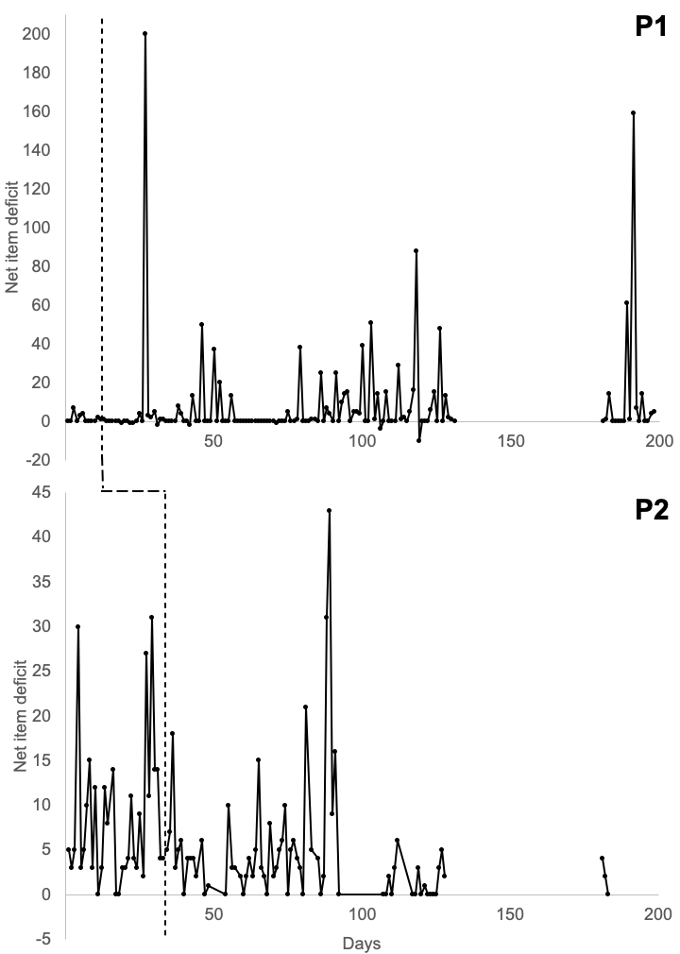
Figure 1. Daily figures for net item deficit (number of items gotten rid of minus number of items acquired) from baseline to six-month follow-up for P1 and P2. A higher deficit indicates more items out than in. Higher numbers indicate improvement. Data points at the end of the intervention phase include data collected immediately following the end of treatment (maintenance).

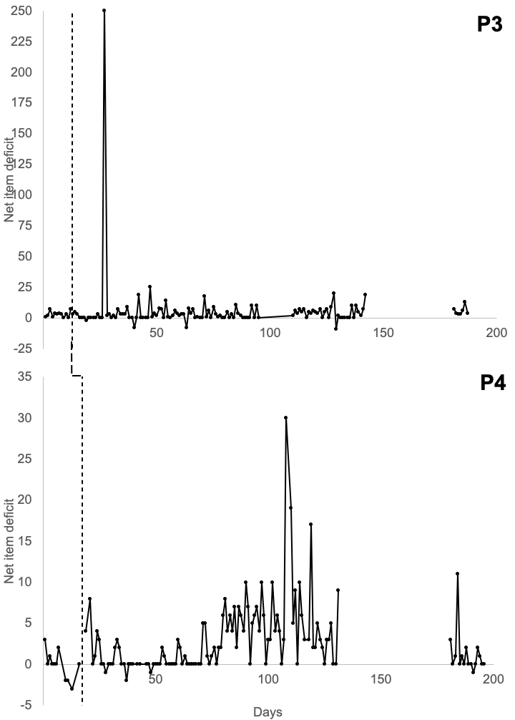
Figure 2. Daily figures for net item deficit (number of items gotten rid of minus number of items acquired) from baseline to six-month follow-up for P3 and P4. A higher deficit indicates more items out than in. Higher numbers indicate improvement. Data points at the end of the intervention phase include data collected immediately following the end of treatment (maintenance).

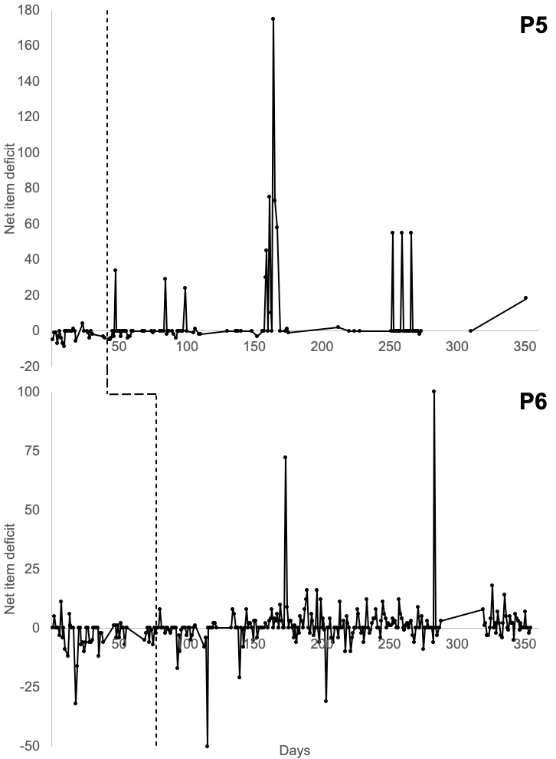
Figure 3. Daily figures for net item deficit (number of items gotten rid of minus number of items acquired) from baseline to six-month follow-up for P5 and P6. A higher deficit indicates more items out than in. Higher numbers indicate improvement. Data points at the end of the intervention phase include data collected immediately following the end of treatment (maintenance).

CRediT Statement
Conceptualization: CWO, MPT; Data curation: CWO, JK, FP, JMP; Formal analysis: CWO; Writing - original draft preparation: CWO, JK, FP, JMP; Writing - review and editing: MEL, MPT.

