Moderators and processes of change in a pilot randomized controlled trial of acceptance-enhanced behavior therapy for trichotillomania in adolescents
Julie M. Petersen
Leila K. Capel
Michael E. Levin
Michael P. Twohig
Utah State University

Correspondence concerning this article should be addressed to Julie Petersen, Department of Psychology, Utah State University, 2810 Old Main Hill, Logan, UT 84322, United States. Phone: (435) 527-5140, Email: Juliana.petersen@usu.edu

Abstract
Treatments for trichotillomania in adolescence have historically been under-researched. This paper presents secondary analyses of treatment moderators and processes of change from a pilot trial assessing the efficacy of teletherapy acceptance-enhanced behavior therapy (AEBT) in adolescents (N = 28). All participants received 10 sessions of AEBT and completed questionnaires at baseline, post-treatment, and longitudinal follow-up from three-, six-, and twelve-months. The moderation effects of baseline general psychological inflexibility, baseline trichotillomania-specific psychological inflexibility, age, and comorbid diagnoses were explored via multilevel modeling using longitudinal outcomes. Comorbid conditions significantly moderated treatment outcome, indicating that more comorbidity was associated with better outcome, even when controlling for pre-treatment trichotillomania severity. No other moderators were significant. Changes in trichotillomania-specific psychological inflexibility from session-by-session data were also examined via multilevel modeling. The results from the models indicated that there was a bidirectional relationship between trichotillomania symptom severity and distress with trichotillomania specific psychological inflexibility. However, review of the slopes from the models suggested that changes in trichotillomania-specific psychological inflexibility may contribute to subsequent improved symptom severity. This study highlights the importance of comorbidity and changes in trichotillomania-specific psychological flexibility during the treatment of youth trichotillomania.
Keywords: trichotillomania, adolescent, acceptance and commitment therapy, processes of change, psychological flexibility
Moderators and Processes of Change in a Pilot Randomized Controlled Trial of Acceptance-Enhanced Behavior Therapy for Trichotillomania in Adolescents
Trichotillomania is characterized by repetitive pulling of hair and results in loss of hair at the site where pulling occurs (American Psychiatric Association [APA], 2013). There is also associated distress and/or functional impairments caused by the pulling (APA, 2013). Trichotillomania has a prevalence rate of 1-3.5% in youth; symptoms usually begin between ages of 10 to 13 years (Franklin et al., 2010; Christenson et al.,1991). Individuals with trichotillomania often report other mental health concerns, including depression, anxiety, and executive functioning difficulties (Flessner et al., 2016; Franklin et al., 2008).
Currently, the most promising adolescent treatment option for trichotillomania is habit reversal training (HRT; Franklin et al., 2011; Rahman et al., 2017). However, more recent research has transitioned to exploring combined treatment options to address internal distress associated with pulling, such as acceptance and commitment therapy (ACT) combined with HRT (also known as acceptance enhanced behavioral therapy [AEBT]; Woods & Twohig, 2008). The research on AEBT is primarily with adult populations (e.g., Lee et al., 2018). However, in a recent pilot randomized controlled trial (MASKED FOR REVIEW), adolescents who received AEBT reported significant decreases in pulling severity as compared to a waitlist, although between condition effects were not significant on other outcomes and processes (MASKED FOR REVIEW). Additionally, medium effect sizes were found for trichotillomania-specific psychological flexibility and a small effect size was seen for trichotillomania-specific distress within the active condition (MASKED FOR REVIEW). These outcomes are promising and suggest the effectiveness of AEBT with adolescents, as well as emphasize the importance of further exploration in patterns of who responded or not to treatment.
With this in mind, research testing moderators for whom AEBT is more or less effective is needed. This is a key aspect of a process-based therapy (PBT) approach in identifying what treatment strategies targeting which processes of change are most effective for which individuals (Hofmann & Hayes, 2018). Currently, there is no research examining moderators of AEBT treatment outcomes for adolescents and there is thus a limited understanding of who will most benefit from this treatment. One moderator that is worthy of examination is psychological inflexibility. Psychological flexibility is willingness to allow the presence of uncomfortable or distressing thoughts, feelings and emotions while still living a life that is consistent with one’s values (Hayes et al., 2006). Therefore, psychological inflexibility is when an individual is no longer living a life in line with their values because they are fighting with thoughts, feelings, and emotions in an effort to make them go away or otherwise rigidly responding to these internal experiences (e.g., acting on urges to pull, fusion with pulling-related thoughts). Theoretically, individuals who are more or less psychologically inflexible may have differential responses to a treatment that aims to target this pathological process. Consistent with a PBT approach, AEBT may be particularly relevant for individuals who are more psychologically inflexible at baseline, and thus would benefit more from treatment engaging this central process. However, prior research testing psychological inflexibility as a moderator of ACT for other mental health concerns among adults has found mixed evidence (e.g., Craske et al., 2014; Davies et al., 2015; Ong et al., 2019). Further research is needed to explore if and how psychological inflexibility moderates outcomes, specifically among adolescents with trichotillomania.
Another moderator worthy of examination is comorbidity with other disorders. Adolescent trichotillomania is commonly comorbid with anxiety and depressive disorders (Franklin et al., 2008). Past results suggest that the presence of comorbid disorders is associated with poorer response to treatment in youth with anxiety and depressive disorders (Franklin et al., 2008; Nilsen et al., 2013). However, research has not evaluated the effect of multiple comorbid diagnoses on trichotillomania symptom severity. Based on preliminary research, it would be expected that multiple comorbid diagnoses would similarly increase trichotillomania symptom severity and limit treatment effects. That said, the ACT components of AEBT may generalize to symptoms other than hairpulling and thus may be effective at decreasing symptom severity of trichotillomania and comorbid diagnoses. However, further research is warranted to better understand this complexity.
Finally, participant age may also play a role in moderating the effect of treatment outcome. The age of onset of trichotillomania is in adolescence (APA, 2013; Franklin et al, 2010), but most treatment research focuses on adults. If the outcomes of AEBT are moderated by age, that would indicate further developmental adaptations may be needed for treating trichotillomania at its onset and/or in adolescents generally. In a systematic review on moderators for treatments of anxiety and depressive disorders, some studies found that age was a significant moderator for younger children, but not older adolescents, while others found non-significant results (Nilsen et al., 2013). Overall, testing age as a moderator is particularly important for research on treatments for adolescents, as findings may provide important information about who will respond best to treatment and which ages may require additional treatment adaptations.
In addition to identifying the characteristics of individuals who may respond best to AEBT, it may be informative to explore how changes in important theorized treatment processes (e.g., psychological inflexibility) contribute to improvements—or lack thereof—at post-treatment and beyond. A compelling explanation for the efficacy of AEBT is found in the aim of increasing psychological flexibility throughout treatment. Adolescent research outside of trichotillomania has also shown that increasing psychological flexibility provides tools necessary to navigate transitions that occur in adolescence (e.g., changing social roles; Halliburton & Cooper, 2015; Swain et al., 2015). However, research has not yet examined the role of psychological inflexibility while adolescents are receiving AEBT. Further, only a handful of studies have explored session-by-session changes in psychological inflexibility and how they relate to treatment outcomes; both Ong (2020) and Twohig (2015) found that changes in psychological flexibility during treatment predicted changes in OCD severity, as opposed to the opposite relationship. While these studies utilized adult samples with OCD, they provide an initial basis for exploring psychological flexibility changes within trichotillomania treatment. Exploring such change is highly important to better understand how improvements are occurring during intervention, allowing for a more detailed understanding of treatment functioning than simple pre- to post-treatment change.
The present study is exploratory and presents secondary analyses aimed at identifying potential moderators and processes of change in AEBT for adolescents with trichotillomania. Specifically, we examined longitudinal moderators for AEBT, including age, comorbidity, baseline general psychological flexibility, and baseline trichotillomania-specific psychological flexibility. Additionally, we examined processes of change using weekly session ratings for trichotillomania-specific psychological flexibility, distress, and symptom severity. Understanding the longitudinal moderators of treatment outcomes may provide information about who will most benefit from treatment and adaptations that may be needed (e.g., to account for age or comorbid problems). Additionally, session-by-session analyses will provide the first test of how psychological flexibility and symptom change interact among adolescents with trichotillomania who are receiving treatment. Thus, we hope the present study is a first step towards a process-based understanding of AEBT for adolescents with trichotillomania.
Method
Data used in the present study was collected from a pilot randomized controlled trial examining the effectiveness and feasibility of AEBT delivered through videoconferencing for adolescents with trichotillomania (MASKED FOR REVIEW). Institutional Review Board approval was received for procedures of the study and all participants (caretakers and adolescents) provided informed consent and assent. Study procedures that are relevant to the present study are described below, information about procedures of the original study and outcomes can be found in the main outcome paper (MASKED FOR REVIEW).
Participants
Twenty-eight adolescents meeting Diagnostic and Statistical Manual- Fifth edition (DSM-5) criteria for trichotillomania as their primary diagnosis participated in the study. To be eligible, participants also had to be searching for trichotillomania specific treatment, between 12-17 years old, fluent in English, not currently receiving alternative psychotherapy, stabilized on relevant medications for 30 days, and reside in [MASKED FOR REVIEW].
Participants reported comorbid diagnoses as part of intake and 16 participants (57.1%) met DSM-V criteria for one or more comorbid diagnoses. Comorbid diagnoses reported include depressive disorders (42.8%) and anxiety disorders (10%). Many participants were taking SSRIs (40%) or ADHD stimulant medication (26%) at the start of the study. The adolescent participants were primarily female (68%) and were between 12-16 years old (M=13.9, SD=1.3).
Procedures
The Psychiatric Institute Trichotillomania Scale and the Mini International Neuropsychiatric Interview were administered during a pre-treatment interview as part of the screening process by a doctoral student. Of the enrolled participants, 14 were randomized into the ACT treatment condition and 14 were randomized into the delayed treatment waitlist condition. The treatment consisted of ten, 50-minute teletherapy sessions delivering AEBT. The waitlist condition waited 12 weeks before receiving 10 weekly sessions of AEBT. Through an online survey, all participants completed self-report measures at five timepoints: pre- and post-treatment, three-, six-, and twelve-month follow-up. Adolescents also completed measures weekly during treatment. Because all conditions ultimately received treatment and completed measures, we combined them for the present study and used the “post waitlist” measures to represent the waitlist participants’ pre-treatment point, as it presented the most conservative method. More information on the treatment and procedures can be found in the original publication (MASKED FOR REVIEW). The present study utilizes all longitudinal follow-up and weekly data from all participants after receiving AEBT.
Measures
Psychiatric Institute Trichotillomania Scale (PITS)
The PITS is a semi-structured diagnostic interview specific for trichotillomania utilized to diagnose trichotillomania in each participant (Winchel et al., 1992). The PITS has six clinician-rated items that assess for the number of hair-pulling sites, duration of pulling and/or time spent thinking about pulling, resistance, interference, distress, and hair loss severity. There is mixed evidence about the reliability and consistency of the PITS (Diefenbach et al., 2005). The present study therefore only utilized this measure to confirm that each participant appropriately met DSM-5 trichotillomania diagnostic criteria.
Mini International Neuropsychiatric Interview for Children and Adolescents 7.0.2 (MINI-KID)
The MINI-KID is a structured diagnostic interview used to assess comorbid diagnoses and was developed for use with children and adolescents. The version used in the outcome paper (MASKED FOR REVIEW) was updated by the developers to match DSM-5 criteria. The MINI-KID has good inter-rater and test-retest reliability; it also has good sensitivity and specificity (Sheehan et al., 2010).
Avoidance and Fusion Questionnaire for Youth- short form (AFQ-Y8; Greco, Lambert, Baer, 2008).
The AFQ-Y8 is a self-report measure of youth psychological inflexibility. Each item on the 8-item measure is rated on a five-point, Likert type scale from zero (Not at all true) to four (Very true). The total score is calculated by summing all items ranging from zero to 32; higher scores indicate higher psychological inflexibility. The AFQ-Y8 demonstrated good internal consistency in the current study sample (α = .87).
Acceptance and Action Questionnaire for Trichotillomania (AAQ-TTM; Houghton et al., 2014)
The AAQ-TTM is a nine-item, self-report measure of trichotillomania symptom specific psychological flexibility developed from the Acceptance and Action Questionnaire-II (AAQ-II; Bond el al. 2011). The nine items are rated on a seven-point, Likert-type scale from one (never true) to seven (always true) and then summed for a total score ranging from 7-63. Higher scores indicate greater psychological flexibility, and lower scores indicate greater psychological inflexibility. The AAQ-TTM demonstrated good internal consistency in the current sample (α = .91).
Trichotillomania Scale for Children-Child Version (TSC-C; Tolin et al. 2008)
The TSC-C is a 12- item child self-report measure of trichotillomania symptom severity in which the child selects the best response option in a multiple-choice format. The responses are then rated on a scale of zero to two and summed to calculate two subscales: symptom severity (TSC-S) and distress/impairment (TSC-D). The TSC-C had good internal consistency in the current sample (α= .89).
Youth Outcome Questionnaire 30.2 Self Report (YOQ-C; Burlingame, Wells, Lambert, & Reisinger, 1998).
The YOQ-C is a self-report measure of distress and well-being. Each item in this 30-item measure is rated on a five-point scale of zero (never or almost never) to four (always or almost always). Scores are then summed for a total score ranging between zero and 120; the clinical cutoff score is 30 or higher. The YOQ-C demonstrated good internal consistency in the current sample (α= .95).
Data analytic plan
All analyses were conducted with R in Rstudio (R Core Team, 2021). The following packages were used in analyses: dplyr (Mailund, 2019), ggplot2 (Wickham, 2011), lme4 (Bates et al., 2007), texreg (Leifeld, 2013), furniture (Barrett & Brignone, 2017), cowplot (Wilke et al., 2019), interactions (Long, 2019), margins (Leeper, 2018), and DataCombine (Gandrud, 2016).
Moderation analyses
Multilevel models (MLMs) with intention-to-treat were used to test moderation effects of demographic variables (age and number of comorbid conditions) and psychological variables (baseline trichotillomania-specific and general psychological inflexibility). Models including an interaction term for time and the moderator, along with a random intercept for each participant. All predictors were mean-centered. Final models used maximum likelihood criteria and p values are based Satterthwaite’s method. As noted previously, the current study combined the waitlist condition after receiving treatment with the active condition. Thus, condition (i.e., assignment to treatment or waitlist) was not utilized in analyses.
Process Analyses
Weekly session-by-session data was utilized for the process of change analyses. Data was lagged in R to create new variables for trichotillomania-specific psychological inflexibility (AAQ-TTM), trichotillomania severity (TSC-S), and trichotillomania distress (TSC-D) for the previous session (i.e., a new set of variables where the session number was one session behind). A model for trichotillomania severity and distress was created, including a fixed effect for AAQ-TTM from the previous session and a random intercept for each participant. A model including an interaction term between AAQ-TTM from the previous session and session number (i.e., time) was also created. These two models were then compared using a Chi-square test to find the best fitting model. The same MLMs were created in reverse (i.e., trichotillomania severity from the previous session as a fixed effect for a MLM predicting AAQ-TTM) and tested following the same process. Marginal effects were calculated for all best-fitting models to inform how each predictor influenced the outcomes while accounting for the effect of model interactions.
Results
See Table 1 for means and standard deviations for all measures across timepoints. See Table 2 for information on the comorbid conditions in the present sample. Tables 3 – 4 contain the regression coefficients and 95% confidence intervals for significant models. Table 5 contains average marginal effect estimates for all process of change models. Figures 1 – 3 show estimated marginal means and error ribbons for all significant models.
Moderation
Comorbid Conditions
The number of diagnosed comorbid conditions was a significant moderator for all outcomes (see Table 2; p < .05). The models for trichotillomania severity and trichotillomania distress also included a significant, separate fixed effect of time, but not for functioning (consistent with prior outcome findings from this trial indicating improvements in symptom severity and distress, but not functioning; MASKED FOR REVIEW). Pre-treatment trichotillomania severity was then added as a fixed effect to these models to examine the individual impact of comorbid conditions (i.e., to confirm that baseline symptom severity was not driving the moderation effect). All moderation effects remained significant after adding pre-treatment trichotillomania severity. Further, pre-treatment trichotillomania severity was found as a significant fixed effect for models predicting trichotillomania severity and distress, but not overall functioning. Pre-treatment trichotillomania severity was then tested as a separate moderator in the same fashion as comorbid conditions but was not found significant.
See Figure 1 for estimated marginal means and error ribbons for the models. These results suggest that participants with greater numbers of comorbid conditions reported greater decreases over time as compared to those with average and/or fewer reported conditions, even when controlling for pre-treatment trichotillomania severity. This was not the expected result—we predicted that individuals with greater comorbidity would report reduced response to treatment based on previous literature on therapy with adolescents (e.g., Nilsen et al., 2013).
Age
Age was not a significant moderator in any model (see supplementary material). Age was also not found as a significant fixed effect. However, there was a significant fixed effect for time in the models for trichotillomania severity and trichotillomania distress, but not functioning—consistent with previous results from the main outcomes of this study.
Baseline Trichotillomania-Specific Psychological Inflexibility
For all outcomes, trichotillomania-specific psychological inflexibility was not a significant moderator (i.e., the interaction with time was not significant; see supplementary material for relevant tables and figures). However, trichotillomania-specific psychological inflexibility was a significant fixed effect for each outcome model. This is an expected and theoretically-consistent result; when time is held constant, greater trichotillomania-specific psychological inflexibility was related to greater trichotillomania severity, trichotillomania distress, and poorer functioning (see supplementary material). The model for trichotillomania severity also included a significant fixed effect of time, indicating significant changes in trichotillomania severity over time; this finding is consistent with the longitudinal outcomes of this study (MASKED FOR REVIEW). There were no other significant time effects, which is particularly interesting because it potentially suggests that trichotillomania-specific psychological inflexibility may account for changes in trichotillomania distress more so than time.
Baseline General Psychological Inflexibility
Similarly, general psychological inflexibility was not found as a significant moderator for outcomes (see supplementary material) but was a significant fixed effect for each model. There were also significant fixed effects for time in all three models. Like trichotillomania-specific psychological inflexibility, these results broadly suggests that changes in general psychological inflexibility are significantly associated with the aforementioned outcomes, even if time is held constant (see supplementary material).
Processes of Change
TSC-S and AAQ-TTM. Both best-fitting MLMs broadly indicated a bidirectional negative relationship between the AAQ-TTM and TSC-S, but no significant effects beside session number (See Table 3). As psychological inflexibility (AAQ-TTM) improved during treatment, trichotillomania severity (TSC-S) decreased and vice versa (See Figure 2a and Figure 3a). However, the steepness of the slope (i.e., strength of the association) appeared to vary depending on session number. For the models with lagged AAQ-TTM (i.e., AAQ-TTM from the previous session) predicting TSC-S, it appears as though the slope grows steeper over time. In other words, the lagged AAQ-TTM seemed to be a stronger predictor of TSC-S as treatment progressed. The average marginal effect estimate for lagged AAQ-TTM on TSC-S was -.35 (p < .001). However, this pattern was not observed in the reverse model; the association between lagged TSC-S and AAQ-TTM did not appear to shift over treatment. The average marginal effect estimate for lagged TSC-S on AAQ-TTM was -.065 (p = .095; see Table 4 for more details).
TSC-D and AAQ-TTM. Similar to the TSC-S, the best-fitting process of change models indicate a bidirectional and negative relationship between the AAQ-TTM and TSC-D (See Table 3). Both models had significant effects for the lagged predictor, but the best-fitting MLM for lagged AAQ-TTM predicting TSC-D did not include session number. As seen in Figure 2b and 3b, higher lagged AAQ-TTM is associated with lower reported trichotillomania distress (TSC-D). The average marginal effect estimate for lagged AAQ-TTM on TSC-D was -.67 (p < .001). While the slopes appear comparable across sessions in both models, it seems that the slopes grow less steep over time when lagged TSC-D predicts AAQ-TTM. In other words, TSC-D from the previous session is possibly a less important predictor for the AAQ-TTM over time. The average marginal effect estimate for lagged TSC-D on AAQ-TTM was -.23 (p < .001; see Table 4).
Discussion
These findings present initial data on moderation and processes of session-by-session change from a pilot trial of AEBT for adolescent trichotillomania. This study is the first to examine session-by-session change in adolescent trichotillomania, and one of the few to explore processes of change and moderation for adolescent samples more broadly. Thus, this study adds important and preliminary information to our understanding of how AEBT might function in young populations.
Moderation
Comorbid conditions were found as a significant moderator for trichotillomania severity and distress over time; individuals with more comorbid conditions had a stronger treatment response (i.e., decrease in symptoms), even when accounting for trichotillomania severity at pre-treatment. These findings demonstrate the influence of comorbid conditions outside of the initial trichotillomania presentation. While unexpected, this provides important data on working with adolescents with trichotillomania, especially given that comorbidity is significantly common with youth trichotillomania (Franklin et al., 2008).
These results add to a nascent but conflicting area of research on the influence of comorbidity on mental health treatment of youth across conditions. For example, a recent review of comorbidity in anxiety and affective disorders in youth found that comorbidity predicts poorer outcomes (Ollendick et al., 2008). However, other researchers have found that lifetime comorbidity is associated with better outcomes (Rohde et al., 2001) or even makes no difference (Birmaher et al., 2000). Alternatively, preliminary support for the positive association between comorbidity and improvement on outcomes was found in a randomized trial comparing ACT to traditional CBT with an adult sample of mixed anxiety disorders, in which a moderation effect indicated ACT was more effective than CBT with clients who had comorbid mood disorders (Wolitzky-Taylor et al., 2012). Because ACT is a transdiagnostic intervention, individuals with multiple diagnoses may report more struggle with symptoms overall, thereby presenting a better fit for transdiagnostic treatments. While the present study utilized AEBT, rather than ACT alone, the ACT processes implemented in treatment are comparable to those in previous studies supporting the relationship between elevated comorbidity and improved treatment response to ACT (Wolitzky-Taylor et al., 2012). Given that youth are also still in the process of developing cognitive and emotional skills (e.g., identifying emotions), it is also possible that individuals who met criteria for more comorbid diagnoses were more aware of their mental health in general and able to articulate such difficulties, thus more easily identifying and describing symptoms that they were struggling with outside of hairpulling. We could hypothesize that such individuals thereby more easily understood the function and process of therapy—either from previous experiences or their own cognitive abilities—and therefore reported an increased response stemming from fuller engagement. However, because we did not measure or account for previous therapy experiences and/or personal awareness, this remains conjecture. Overall, there is no research on the impact of comorbidity on treatment outcomes of trichotillomania in adolescents; this is a novel finding that adds to a pool of growing knowledge about comorbidity in general.
Alternatively, age was not found as a significant moderator of longitudinal outcomes in the present sample. This lack of significance is theoretically consistent with research on the importance of adapting to developmental ability, rather than age, when working with young people (e.g., Sauter et al., 2009). There is one other study to date examining age as a predictor of treatment response in trichotillomania; age was found as a significant predictor of outcomes following comprehensive behavioral treatment for adults with trichotillomania (Coyne, 2021). Some researchers suggest that there may be differences in trichotillomania presentation across age groups (e.g., more focused pulling, urges, and reduced resistance in older youth; Panza et al., 2013, Schumer et al., 2015), while others have found stability in symptom severity between age groups (Walther et al., 2014). It is possible that these presentation differences are not accurately captured by age, but further research is needed.
Lastly, neither baseline trichotillomania-specific nor baseline general psychological inflexibility were significant moderators. Because AEBT is thought to function, in part, by improving psychological inflexibility, we had predicted that beginning levels of psychological inflexibility would impact longitudinal levels of trichotillomania-related severity and distress (i.e., greater inflexibility at the start would contribute to greater gains over time). These results suggest that initial psychological inflexibility may not impact long-term gains after treatment. The impact of initial psychological inflexibility on treatment outcome is highly understudied in youth samples. As the one example, Beeckman and colleagues (2019) found that psychological inflexibility acted as a predictor of better functioning in children with chronic pain. Previous studies with adults have found mixed results in terms of whether and how baseline psychological inflexibility moderates ACT effects on mental health (e.g., Craske et al., 2014; Davies et al., 2015; Ong et al., 2019). Consistent with a process-based therapy approach seeking to match therapeutic procedures and processes to ideographic client case conceptualizations (Hofmann & Hayes, 2018), further research is needed to clarify if and how baseline psychological inflexibility, among other relevant psychological processes measured at pre-treatment, predicts who responds best to what treatment.
Processes of Change
For our exploration of session-by-session change, we assessed trichotillomania-specific psychological inflexibility (AAQ-TTM) at the previous session as a predictor of trichotillomania severity (TSC-S) and distress (TSC-D) and vice versa. In the models using AAQ-TTM and TSC-S, results indicated only a significant effect of session number (i.e., time). However, review of the slopes suggested that changes in trichotillomania-specific psychological inflexibility may contribute to subsequent improved symptom severity. The findings from visual inspection of the slopes are broadly consistent with the theory behind AEBT; as the client works to build psychological flexibility in response to their urges (e.g., via skills like defusion), they strengthen the ability to let urges be and not respond to them (i.e., resisting pulling), subsequently contributing to reduced severity.
For the AAQ-TTM and TSC-D, we found bidirectional relationships across the best-fitting models. As in, we found that TSC-Distress acted as a significant predictor of AAQ-TTM and vice versa. Because AEBT, like ACT in general, does not target distress reduction, the bidirectional relationship between the TSC-D and AAQ-TTM is theoretically consistent. However, the best-fitting model for AAQ-TTM as a predictor of TSC-D did not include session, unlike the model using TSC-D as a predictor of AAQ-TTM. This suggests that building trichotillomania-specific psychological flexibility across treatment may be especially important as a factor for contributing to reduced trichotillomania-related distress. Again, these results are theoretically consistent with the basis of AEBT; as the adolescent builds psychological flexibility throughout treatment, they become more open to experiencing urges and other trichotillomania symptoms and theoretically are less distressed by them. However, this conjecture should be further confirmed by other research studies.
Overall, there is very little research available on trichotillomania and/or processes of change in ACT with youth. While not from treatment outcome studies specifically, there is evidence suggesting that psychological flexibility and related constructs (e.g., acceptance) contributed to positive outcomes like improved functioning and prosocial behavior (e.g., Ciarrochi et al., 2011). This study adds to these findings, presenting preliminary data that suggests the importance of trichotillomania-specific psychological flexibility throughout the treatment of youth trichotillomania. However, further research must occur to confirm and grow our understanding of how psychological flexibility functions during treatment of youth clinical samples.
Clinical Implications
First, this study suggests that comorbidity may not be a serious concern when using AEBT to treat trichotillomania in youth, regardless of the trichotillomania severity. Previous work with adolescents has emphasized the transdiagnostic nature of ACT (Coyne et al., 2011); it is thereby possible that AEBT may be an appropriate treatment even if the adolescent is reporting comorbid symptoms or other conditions. Previous research on the treatment of trichotillomania found comparable comorbidity in their samples (Franklin et al., 2011); however, there are a few differences that have important clinical implications. The participants of this study reported a greater number of mood and anxiety disorders than past RCTs for the treatment of youth trichotillomania (e.g., Franklin et al., 2011). Because our sample was exclusively adolescents, it would be expected to see a greater number of mood and anxiety disorder diagnoses, as these problems are more prevalent in adolescents than children (World Health Organization, 2021). Our study also did not exclude for other conditions commonly excluded from RCTs, such as symptoms of mania or autism spectrum disorder. It may be important for clinicians to be mindful of clinical complications and/or comorbidity that can accompany adolescent clients, especially those seeking treatment for trichotillomania. Although the present study results indicate that comorbidity may not impact outcomes in a negative manner, understanding comorbidity may be helpful for identifying primary diagnoses and making treatment plans.
Similar results can be drawn from our results on moderation with age, suggesting that AEBT can be applied for a range of young people. If age was a significant moderator, then it would suggest that AEBT is only appropriate for a specific time in adolescence. However, the lack of significance suggests that the treatment is appropriate across the developmental spectrum. Lastly, our process-of-change outcomes highlight the unique importance of changes in trichotillomania-specific psychological flexibility during AEBT with youth. When utilizing AEBT with youth, it is likely important to measure this construct and focus treatment on building psychologically flexible responses to urges throughout treatment.
Limitations
Despite these promising results, this study had several major limitations worth highlighting. First, as discussed in previous papers utilizing this dataset (e.g., MASKED FOR REVIEW), this pilot study is small, particularly with the number of individuals lost to follow-up, and had limited diversity. Because our sample was largely homogenous, it would be important to explore other demographic moderators for treatment outcome in the future (e.g., race, gender identity). Second, the secondary comorbid diagnoses were based on criteria met using the MINI-Kid. More rigorous approaches to diagnoses (e.g., specific discernment between which diagnoses were most relevant besides the primary diagnosis of trichotillomania) might find alternate results. Furthermore, we did not measure nor account for the severity of the comorbid diagnoses. It is therefore difficult to ascertain the true influence of comorbidity across the sample. It is possible that participants met criteria for another disorder but were within the very mild range. It is also possible that participants met criteria for another disorder, and they were equally impaired by both trichotillomania and the secondary diagnosis, but in different manners. It may be beneficial for future research to utilize clinical severity measures to gauge the clinical impact of all aspects of the participants’ presentations. Lastly, there are a few measurement limitations to note. The AAQ-TTM has not been validated on youth, and we therefore cannot completely discern whether the results are accurately capturing psychological flexibility specific to trichotillomania in youth. Furthermore, the present study focuses on child-report only and the use of multiple informants can be important when trying to capture youth symptomology. Future research on youth trichotillomania should incorporate the caretaker perspective, alongside behavioral tracking (e.g., how many hairs pulled per week).
Conclusion
In sum, research on treatment moderators and processes of change in youth, especially with trichotillomania, is nascent. The present study adds information to our understanding of how AEBT might work, building on the available evidence for acceptance-based treatments with youth more broadly. This study also contributes to a growing process-based therapy literature clarifying the processes of change and moderators of treatment success in order to guide ideographic case conceptualization and treatment planning focused on therapeutic processes of change.

Acknowledgments

This study was supported by funding from the Huntsman Foundation.

References
American Psychiatric Association, Diagnostic and statistical manual of mental disorders (DSM- 5®). 2013, Arlington, VA: Author.
Barrett, T. S., & Brignone, E. (2017). Furniture for Quantitative Scientists. R Journal, 9(2), 142.
Bates, D., Sarkar, D., Bates, M. D., & Matrix, L. (2007). The lme4 package. R package version, 2(1), 74.
Beeckman, M., Hughes, S., Van Ryckeghem, D., Van Hoecke, E., Dehoorne, J., Joos, R., & Goubert, L. (2019). Resilience factors in children with juvenile idiopathic arthritis and their parents: The role of child and parent psychological flexibility. Pain Medicine, 20(6), 1120-1131.
Birmaher, B., Brent, D. A., Kolko, D., Baugher, M., Bridge, J., Holder, D., Iyengar, S., & Ulloa, R. E. (2000). Clinical outcome after short-term psychotherapy for adolescents with major depressive disorder. Archives of General Psychiatry, 57(1), 29-36.
Burlingame, G. M., Wells, M. G., Lambert, M. J., & Cox, J. C. (2014). Youth outcome questionnaire. In The use of psychological testing for treatment planning and outcomes assessment (pp. 235-274). Routledge.
Ciarrochi, J. V., Kashdan, T. B., Leeson, P., Heaven, P., & Jordan, C. (2011). On being aware and accepting: A one-year longitudinal study into adolescent well-being. Journal of Adolescence, 34(4), 695-703. doi:10.1016/j.adolescence.2010.09.003
Christenson, G. A., Pyle, R. L., & Mitchell, J. E. (1991). Estimated lifetime prevalence of trichotillomania in college students. The Journal of Clinical Psychiatry, 52(10), 415–417.
Cohen, G. L., & Sherman, D. K. (2014). The psychology of change: Self-affirmation and social psychological intervention. Annual Review of Psychology, 65, 333-371.
Coyne, A. (2021). Predictors of Treatment Response and Relapse for Comprehensive Behavioral Treatment of Trichotillomania (Masters thesis, American University).
Coyne, L. W., McHugh, L., & Martinez, E. R. (2011). Acceptance and commitment therapy (ACT): Advances and applications with children, adolescents, and families. Child and Adolescent Psychiatric Clinics, 20(2), 379-399.
Craske, M.G., Niles, A.N., Burklund, L.J., Wolitzky-Taylor, K.B., Vilardaga, J.C.P., Arch, J. J., Saxbe, D. E., & Lieberman, M.D. (2014). Randomized controlled trial of cognitive behavioral therapy and acceptance and commitment therapy for social phobia: Outcomes and moderators. Journal of Consulting and Clinical Psychology, 82, 1034-1048.
Davies, C.D., Niles, A.N., Pittig, A., Arch, J.J. & Craske, M.G. (2015). Physiological and behavioral indices of emotion dysregulation as predictors of outcome from cognitive behavioral therapy and acceptance and commitment therapy for anxiety. Journal of Behavior Therapy and Experimental Psychiatry, 46, 35-43.
Diefenbach, G. J., Tolin, D. F., Crocetto, J., Maltby, N., & Hannan, S. (2005). Assessment of trichotillomania: A psychometric evaluation of hair-pulling scales. Journal of Psychopathology and Behavioral Assessment, 27(3), 169-178.
Flessner, C. A., Brennan, E., Murphy, Y. E., & Francazio, S. (2016). Impaired executive functioning in pediatric trichotillomania (Hair Pulling Disorder). Depression and Anxiety, 33(3), 219-228.
Franklin, M. E., Flessner, C. A., Woods, D. W., Keuthen, N. J., Piacentini, J. C., Moore, P., ... & Board, T. L. C. S. A. (2008). The child and adolescent trichotillomania impact project: Descriptive psychopathology, comorbidity, functional impairment, and treatment utilization. Journal of Developmental & Behavioral Pediatrics, 29(6), 493-500.
Franklin, M. E., Edson, A. L., & Freeman, J. B. (2010). Behavior therapy for pediatric trichotillomania: Exploring the effects of age on treatment outcome. Child and Adolescent Psychiatry and Mental Health, 4(1), 1-6.
Franklin, M. E., Zagrabbe, K., & Benavides, K. L. (2011). Trichotillomania and its treatment: A review and recommendations. Expert Review of Neurotherapeutics, 11(8), 1165-1174.
Greco, L. A., Lambert, W., & Baer, R. A. (2008). Psychological inflexibility in childhood and adolescence: development and evaluation of the Avoidance and Fusion Questionnaire for Youth. Psychological Assessment, 20(2), 93.
Haaland, A.T., Eskeland, S.O., Moen, E.M, Vogel, P.A., Haseth, S., Mellingen, K., Himle, J.A., Woods, D.W., & Hummelen, B. (2017). ACT-enhanced behavior therapy in group format for trichotillomania: An effectiveness study. Journal of Obsessive-Compulsive and Related Disorders, 12, 109-116.
Halliburton, A. E., & Cooper, L. D. (2015). Applications and adaptations of Acceptance and Commitment Therapy (ACT) for adolescents. Journal of Contextual Behavioral Science, 4(1), 1-11. doi:10.1016/j.jcbs.2015.01.002
Houghton, D.C., Compton, S.N., Twohig, M.P., Saunders, S.M., Franklin, M.E., Neal-Barnett, A.M., Ely, L., Capriotti, M.R., & Woods, D.W. (2014). Measuring the role of psychological inflexibility in trichotillomania. Psychiatry Research, 220 (1-2), 356-361. https://doi.org/10.1016/j.psychres.2014.08.003
Lee, E. B., Homan, K. J., Morrison, K. L., Ong, C. W., Levin, M. E., & Twohig, M. P. (2020). Acceptance and commitment therapy for trichotillomania: A randomized controlled trial of adults and adolescents. Behavior modification, 44(1), 70-91.
Leifeld, P. (2013). texreg: Conversion of statistical model output in R to LATEX and HTML tables. Journal of Statistical Software, 55(8), 1-24.
Lewin, A. B., Piacentini, J., Flessner, C. A., Woods, D. W., Franklin, M. E., Keuthen, N. J., ... & Stein, D. J. (2009). Depression, anxiety, and functional impairment in children with trichotillomania. Depression and Anxiety, 26(6), 521-527.
Gandrud, C. (2016). Package ‘DataCombine’. R package version 0.2.21.
Greco, L. A., Lambert, W., & Baer, R. A. (2008). Psychological inflexibility in childhood and adolescence: development and evaluation of the Avoidance and Fusion Questionnaire for Youth. Psychological Assessment, 20(2), 93.
Hofmann, S. G., & Hayes, S. C. (2018). The future of intervention science: Process-based therapy. Clinical Psychological Science, 1-14.
Hox, J. J., Moerbeek, M., & van de Schoot, R. (2017). Multilevel Analysis: Techniques and Applications (3rd ed.). New York, NY: Routledge.
Leeper, T. J. (2018). margins: Marginal effects for model objects. R package version 0.3.23.
Little, T. D. (2013). Longitudinal Structural Equation Modeling. Guilford press.
Long, J.A. (2019). interactions: Comprehensive, User-Friendly Toolkit for Probing Interactions. R package version 1.1.0, https://cran.r-project.org/package=interactions.
Mailund, T. (2019). Manipulating data frames: dplyr. In R Data Science Quick Reference (pp. 109-160). Apress, Berkeley, CA.
Marshall, S. L., Parker, P. D., Ciarrochi, J., Sahdra, B., Jackson, C. J., & Heaven, P. C. (2015). Self-compassion protects against the negative effects of low self-esteem: A longitudinal study in a large adolescent sample. Personality and Individual Differences, 74, 116-121.
Nilsen, T. S., Eisemann, M., & Kvernmo, S. (2013). Predictors and moderators of outcome in child and adolescent anxiety and depression: A systematic review of psychological treatment studies. European Child & Adolescent Psychiatry, 22(2), 69-87.
Ollendick, T. H., Jarrett, M. A., Grills-Taquechel, A. E., Hovey, L. D., & Wolff, J. C. (2008). Comorbidity as a predictor and moderator of treatment outcome in youth with anxiety, affective, attention deficit/hyperactivity disorder, and oppositional/conduct disorders. Clinical Psychology Review, 28(8), 1447-1471.
Ong, C. W., Barney, J. L., Barrett, T. S., Lee, E. B., Levin, M. E., & Twohig, M. P. (2019). The role of psychological inflexibility and self-compassion in acceptance and commitment therapy for clinical perfectionism. Journal of Contextual Behavioral Science, 13, 7-16.
Ong, C. W., Blakey, S. M., Smith, B. M., Morrison, K. L., Bluett, E. J., Abramowitz, J. S., & Twohig, M. P. (2020). Moderators and processes of change in traditional exposure and response prevention (ERP) versus acceptance and commitment therapy-informed ERP for obsessive-compulsive disorder. Journal of Obsessive-Compulsive and Related Disorders, 24, 100499.
Panza, K. E., Pittenger, C., & Bloch, M. H. (2013). Age and gender correlates of pulling in pediatric trichotillomania. Journal of the American Academy of Child & Adolescent Psychiatry, 52(3), 241-249.
Petersen, J.M., Barney, J.L., Fruge, J.E., Lee, E.B., Levin, M.E., & Twohig, M. P. (in press). Longitudinal outcomes from a pilot randomized controlled trial of telehealth acceptance- enhanced behavior therapy for adolescents with trichotillomania. Journal of Obsessive- Compulsive and Related Disorders.
Rahman, O., McGuire, J., Storch, E. A., & Lewin, A. B. (2017). Preliminary randomized controlled trial of habit reversal training for treatment of hair pulling in youth. Journal of Child and Adolescent Psychopharmacology, 27(2), 132-139.
R Core Team (2021). R: A language and environment for statistical computing. R Foundation for Statistical Computing, Vienna, Austria. https://www.R-project.org/.
Rohde, P., Clarke, G. N., Lewinsohn, P. M., Seeley, J. R., & Kaufman, N. K. (2001). Impact of comorbidity on a cognitive-behavioral group treatment for adolescent depression. Journal of the American Academy of Child & Adolescent Psychiatry, 40(7), 795-802.
Sauter, F. M., Heyne, D., & Westenberg, P.M. (2009). Cognitive behavior therapy for anxious adolescents: Developmental influences on treatment design and delivery. Clinical Child and Family Psychology Review, 12(4), 310-335.
Schumer, M. C., Panza, K. E., Mulqueen, J. M., Jakubovski, E., & Bloch, M. H. (2015). Long‐ term outcome in pediatric trichotillomania. Depression and Anxiety, 32(10), 737-743.
Sheehan, D.V., Sheenhan, K.H., Shytle, R.D., Janavs, J., Bannon, Y., Rogers, J.E., Milo, K.M., Stock, S.L., & Wilkinson, B. (2010). Reliability and validity of the mini international neuropsychiatric interview for children and adolescents (MINI-KID). Journal of Clinical Psychiatry, 71(3), 313-326.
Swain, J., Hancock, K., Dixon, A., & Bowman, J. (2015). Acceptance and commitment therapy for children: A systematic review of intervention studies. Journal of Contextual Behavioral Science, 4(2), 73-85.
Tolin, D. F., Diefenbach, G. J., Flessner, C. A., Franklin, M. E., Keuthen, N. J., Moore, P. S., . . . Board, T. L. C. S. A. (2008). The Trichotillomania Scale for Children: Development and validation. Child Psychiatry and Human Development, 39(3), 331-349.
Twohig, M. P., Vilardaga, J. C. P., Levin, M. E., & Hayes, S. C. (2015). Changes in psychological flexibility during acceptance and commitment therapy for obsessive compulsive disorder. Journal of Contextual Behavioral Science, 4(3), 196-202.
Twohig, M. P., Petersen, J. M., Fruge, J., Ong, C. W., Barney, J. L., Krafft, J., ... & Levin, M. E. (2021). A pilot randomized controlled trial of online-delivered ACT-enhanced behavior therapy for trichotillomania in adolescents. Cognitive and Behavioral Practice.
Walther, M. R., Snorrason, I., Flessner, C. A., Franklin, M. E., Burkel, R., & Woods, D. W. (2014). The trichotillomania impact project in young children (TIP-YC): Clinical characteristics, comorbidity, functional impairment and treatment utilization. Child Psychiatry & Human Development, 45(1), 24-31.
Wickham, H. (2011). ggplot2. Wiley Interdisciplinary Reviews: Computational Statistics, 3(2), 180-185.
Wilke, C. O., Wickham, H., & Wilke, M. C. O. (2019). Package ‘cowplot’. Streamlined Plot Theme and Plot Annotations for ‘ggplot2.
Winchel, R. M., Jones, J. S., Molcho, A., Parsons, B., Stanley, B., & Stanley, M. A. (1992). The psychiatric institute trichotillomania scale (PITS). Psychopharmacology Bulletin, 28, 463–476.
Wolitzky-Taylor, K. B., Arch, J. J., Rosenfield, D., & Craske, M. G. (2012). Moderators and non-specific predictors of treatment outcome for anxiety disorders: A comparison of cognitive behavioral therapy to acceptance and commitment therapy. Journal of Consulting and Clinical Psychology, 80(5), 786–799.
Woods, D.W., & Twohig, M.P (2008). Acceptance Enhanced Behavioral Therapy: Treatments that Work.
Woods, D. W., & Houghton, D. C. (2014). Diagnosis, evaluation, and management of trichotillomania. Psychiatric Clinics, 37(3), 301-317.
World Health Organization. (2021, November 17). Adolescent mental health. World Health Organization. Retrieved September 27, 2022, from https://www.who.int/news-room/fact- sheets/detail/adolescent-mental-health
Yeager, D. S., & Dweck, C. S. (2012). Mindsets that promote resilience: When students believe that personal characteristics can be developed. Educational psychologist, 47(4), 302-314.
Table 1
Means and standard deviations for all measures.
 | Pretreatment | Posttreatment | Three-month follow-up | Six-month follow-up | 12-month follow-up
TSC-Severity | 1.3 (0.4) | 0.6 (0.6) | 0.8 (0.5) | 0.7 (0.5) | 0.7 (0.6)
TSC-Distress | 0.8 (0.5) | 0.5 (0.5) | 0.5 (0.6) | 0.4 (0.5) | 0.5 (0.6)
AFQ-Y8 | 6.1 (6.0) | 5.8 (4.7) | 5.4 (5.6) | 7.2 (8.0) | 7.2 (7.0)
AAQ-TTM¹ | 42.0 (12.7) | 47.5 (13.5) | 47.8 (13.0) | 49.1 (13.7) | 48.3 (13.6)
YOQ-C | 25.0 (21.5) | 22.1 (14.9) | 17.4 (13.7) | 19.8 (19.0) | 22.1 (18.7)
Note. TSC = Trichotillomania Scale for Children (Youth-Report); AFQ-Y8 = Avoidance and Fusion Questionnaire for Youth; AAQ-TTM = Acceptance and Action Questionnaire for Trichotillomania; YOQ-C = Youth Outcomes Questionnaire (Youth-Report).
¹Higher scores indicate greater improvement.

Table 2
Comorbid diagnoses present in the full sample.
Frequency (%)
N = 28
Any diagnosis | 14 (50%)
Depressive episode | 6 (42.8%)
Current hypomanic symptoms | 1 (3.6%)
Panic disorder | 3 (10.7%)
Agoraphobia | 3 (10.7%)
Separation anxiety | 2 (7.1%)
Social anxiety | 3 (10.7%)
Specific phobia | 2 (7.1%)
OCD² | 1 (3.6%)
Tic disorder | 3 (10.7%)
ADHD³ | 3 (10.7%)
Anorexia nervosa | 1 (3.6%)
GAD⁴ | 2 (7.1%)
ASD⁵ | 4 (14.3%)
Note. OCD = Obsessive Compulsive Disorder; ADHD = Attention Deficit Hyperactivity Disorder; GAD = Generalized Anxiety Disorder; ASD = Autism Spectrum Disorder cannot be ruled out.

Table 3
Regression coefficients and 95% confidence intervals from multilevel models for comorbid conditions as a moderator for the TSC-Y Severity and TSCC-D, and YOQC while controlling for pre-treatment trichotillomania severity.

 | TSC-Severity | TSC-Distress | YOQC
(Intercept) | 1.04 [ 0.89; 1.18] * | 0.69 [ 0.52; 0.87] * | 23.78 [18.92; 28.63] *
Comorbidity | 0.05 [-0.11; 0.21] | 0.08 [-0.11; 0.27] | 11.73 [ 6.43; 17.04] *
Weeks | -0.01 [-0.01; -0.00] * | -0.00 [-0.01; -0.00] * | -0.04 [-0.11; 0.04]
Pre-treatment TSC-S | 0.27 [ 0.13; 0.40] * | 0.19 [ 0.01; 0.37] * | 2.92 [-2.00; 7.84]
Comorbidity x Weeks | -0.01 [-0.01; -0.00] * | -0.00 [-0.00; -0.00] * | -0.13 [-0.20; -0.06] *
AIC | 160.75 | 106.32 | 834.92
BIC | 179.39 | 124.96 | 853.50
Log Likelihood | -73.38 | -46.16 | -410.46
Number of observations | 106 | 106 | 105
*p < .05
Note. TSC-S = Trichotillomania Scale for Children (Youth-Report) - Severity; YOQC = Youth Outcomes Questionnaire Child-Report; AIC = Akaike Information Criterion; BIC = Bayesian Information Criterion.

Table 4
Regression coefficients and 95% confidence intervals from multilevel models for process of change analyses.
 | Lagged TSC-S x session predicting AAQ-TTM | Lagged AAQ-TTM x session predicting TSC-S |  | Lagged TSC-D x session predicting AAQ-TTM | Lagged AAQ-TTM predicting TSC-D
(Intercept) | -0.22 [-0.61; 0.17] | 0.38 [ 0.06; 0.69] * |  | -0.18 [-0.51; 0.16] | -0.04 [-0.20; 0.13]
Lagged TSC-S | -0.02 [-0.16; 0.11]
Session | 0.03 [ 0.01; 0.05] * | -0.07 [-0.11; -0.03] * |  | 0.03 [ 0.01; 0.05] *
Lagged TSC-S x session | -0.01 [-0.03; 0.01]
Lagged TSC-D |  |  |  | -0.17 [-0.32; -0.02] *
Lagged TSC-D x session |  |  |  | -0.01 [-0.03; 0.01]
Lagged AAQ-TTM |  | -0.14 [-0.43; 0.15] |  |  | -0.67 [-0.80; -0.54] *
Lagged AAQ-TTM x session |  | -0.04 [-0.07; 0.00]
AIC | 213.14 | 415.07 |  | 198.38 | 312.47
BIC | 232.43 | 434.39 |  | 217.70 | 325.37
Log Likelihood | -100.57 | -201.53 |  | -93.19 | -152.23
Number of observations | 184 | 185 |  | 185 | 186
*p < .05
Note. TSC-S = Trichotillomania Scale for Children (Youth-Report) - Severity; TSC-D = Trichotillomania Scale for Children (Youth-Report) – Distress; TTM-AAQ = Acceptance and Action Questionnaire for Trichotillomania; AIC = Akaike Information Criterion; BIC = Bayesian Information Criterion.

Table 5
Average marginal effect estimates, confidence intervals (CI), and p-values for all models.

Predictors | Outcomes | Average Marginal Effect Estimate | Lower CI | Upper CI | p
Lagged TSC-S | AAQ-TTM | -.065 | -.14 | .01 | .095
Session |  | .032 | .013 | .05 | .001
Lagged TSC-D | AAQ-TTM | -.23 | -.33 | -.13 | <.001
Session |  | .027 | .008 | .04 | .005
Lagged AAQ-TTM | TSCS | -.35 | -.53 | -.17 | <.001
Session |  | -.07 | -.11 | -.032 | <.001
Lagged AAQ-TTM | TSCD | -.67 | -.80 | -.54 | <.001
Note. TSC-S = Trichotillomania Scale for Children (Youth-Report) - Severity; TSC-D = Trichotillomania Scale for Children (Youth-Report) – Distress; TTM-AAQ = Acceptance and Action Questionnaire for Trichotillomania.

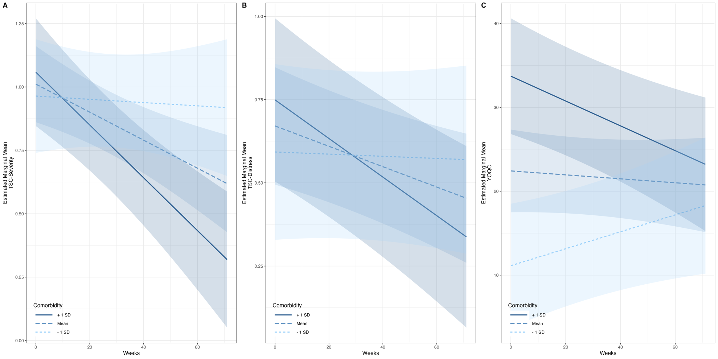

Figure 1. Estimated marginal means and error ribbons from the models with comorbid conditions as a moderator and pre-treatment TSC-S as a fixed effect predicting A) TSC- Severity, B) TSC-Y Distress, and C) YOQC. TSC = Trichotillomania Scale for Children (Youth-Report); YOQC = Youth Outcomes Questionnaire Child-Report.

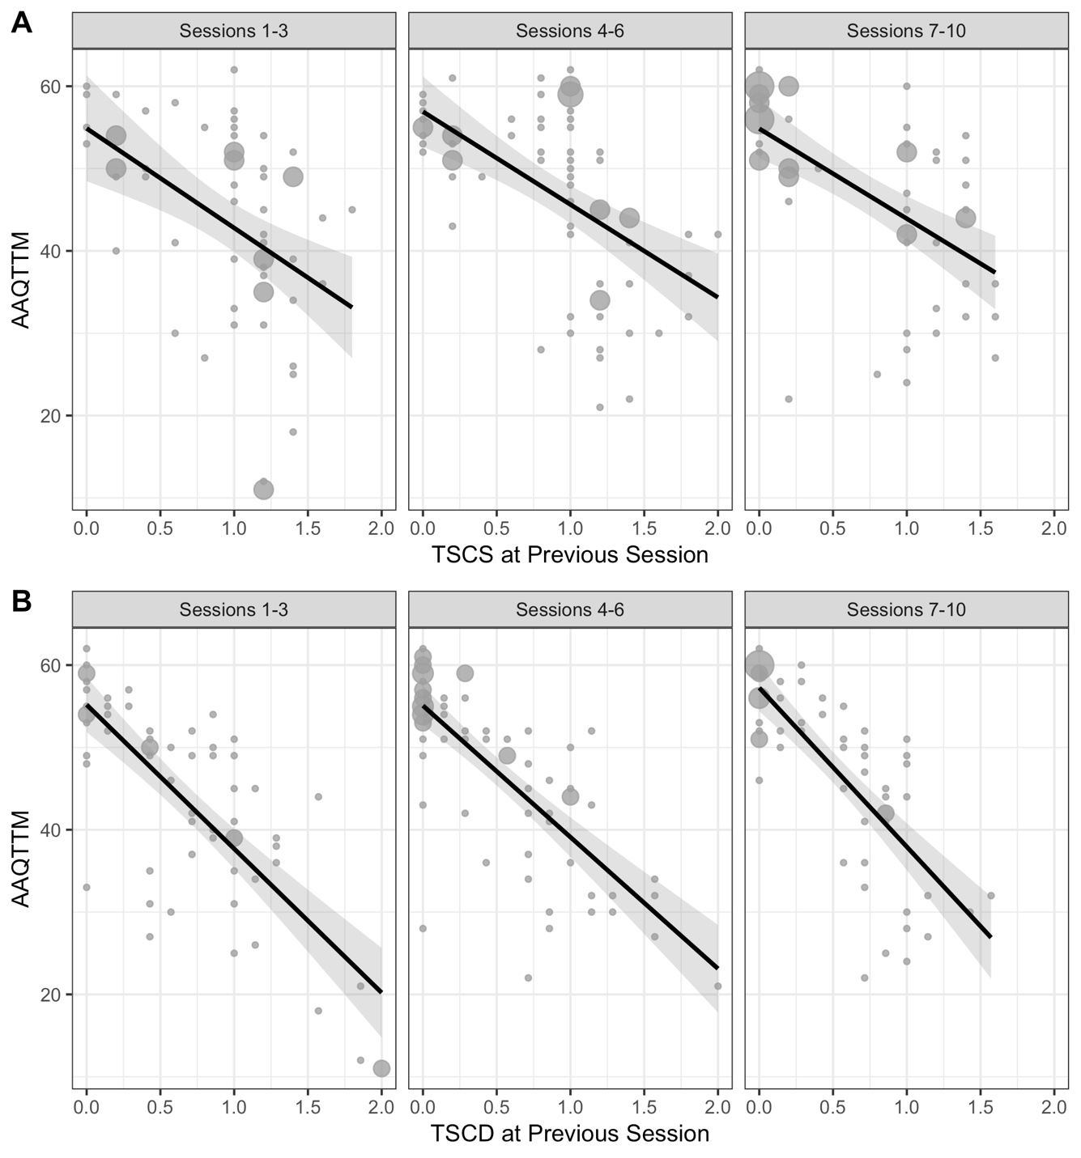
Figure 2.
Estimated marginal means and error ribbons from the models predicting AAQ-TTM using TSC-S (panel A) and TSC-D (panel B) from the previous session (i.e., lagged). TSC-S = Trichotillomania Scale for Children (Youth-Report) - Severity; TSC-D = Trichotillomania Scale for Children (Youth-Report) – Distress; TTM-AAQ = Acceptance and Action Questionnaire for Trichotillomania.

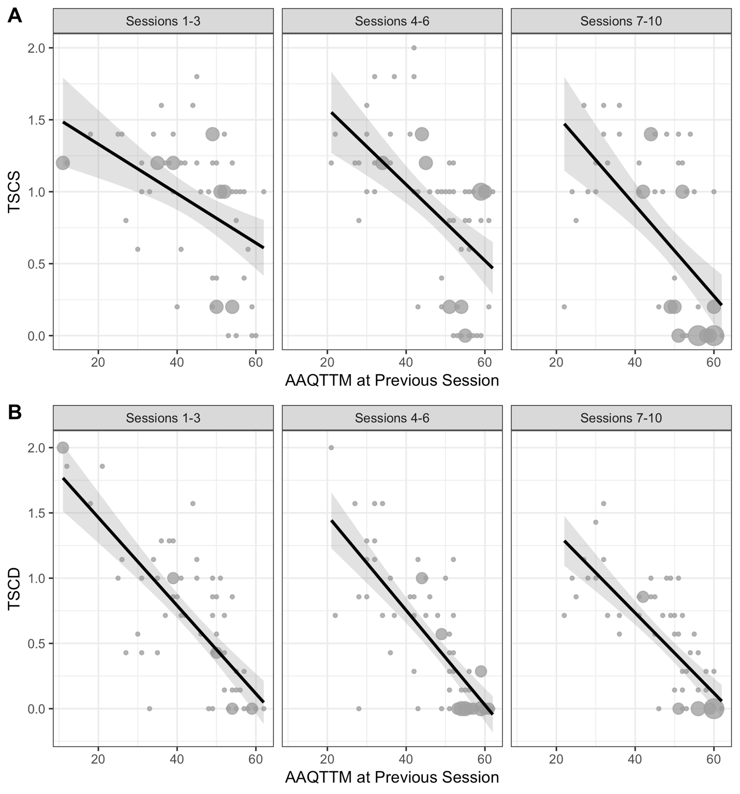
Figure 3.
Estimated marginal means and error ribbons from the models predicting TSC-S (panel A) and TSC-D (panel B) using AAQ-TTM from the previous session (i.e., lagged). TSC-S = Trichotillomania Scale for Children (Youth-Report) - Severity; TSC-D = Trichotillomania Scale for Children (Youth-Report) – Distress; TTM-AAQ = Acceptance and Action Questionnaire for Trichotillomania.

